MYSQL Assignment -8

Q1) Assume each salesperson has a 12% commission .Write a query on the orders table that will produce the order number, the salesperson number, and the amount of the salesperson’S commission for that order.
Solve -
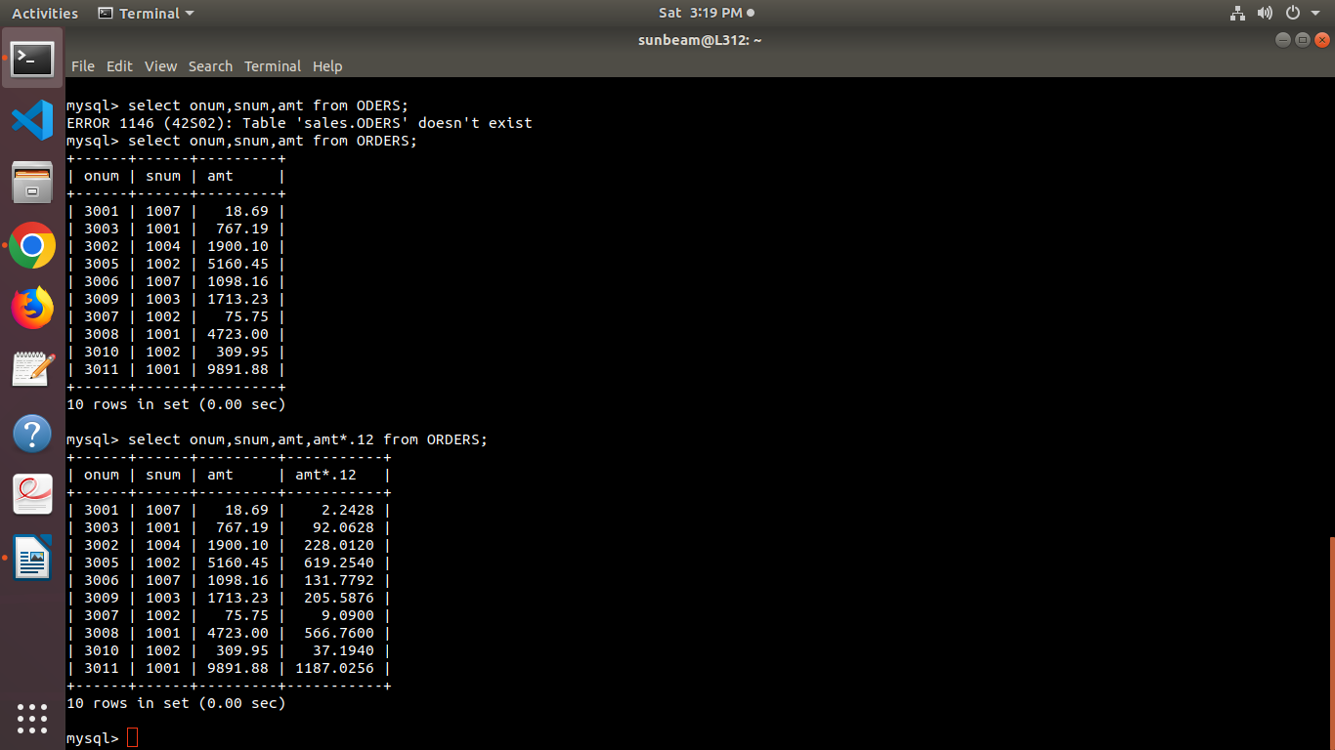
Q2) write a Query on the Customers table that will find the highest rating in each city. Put the output in this form :

for the city(city),the highest rating is : (rating)
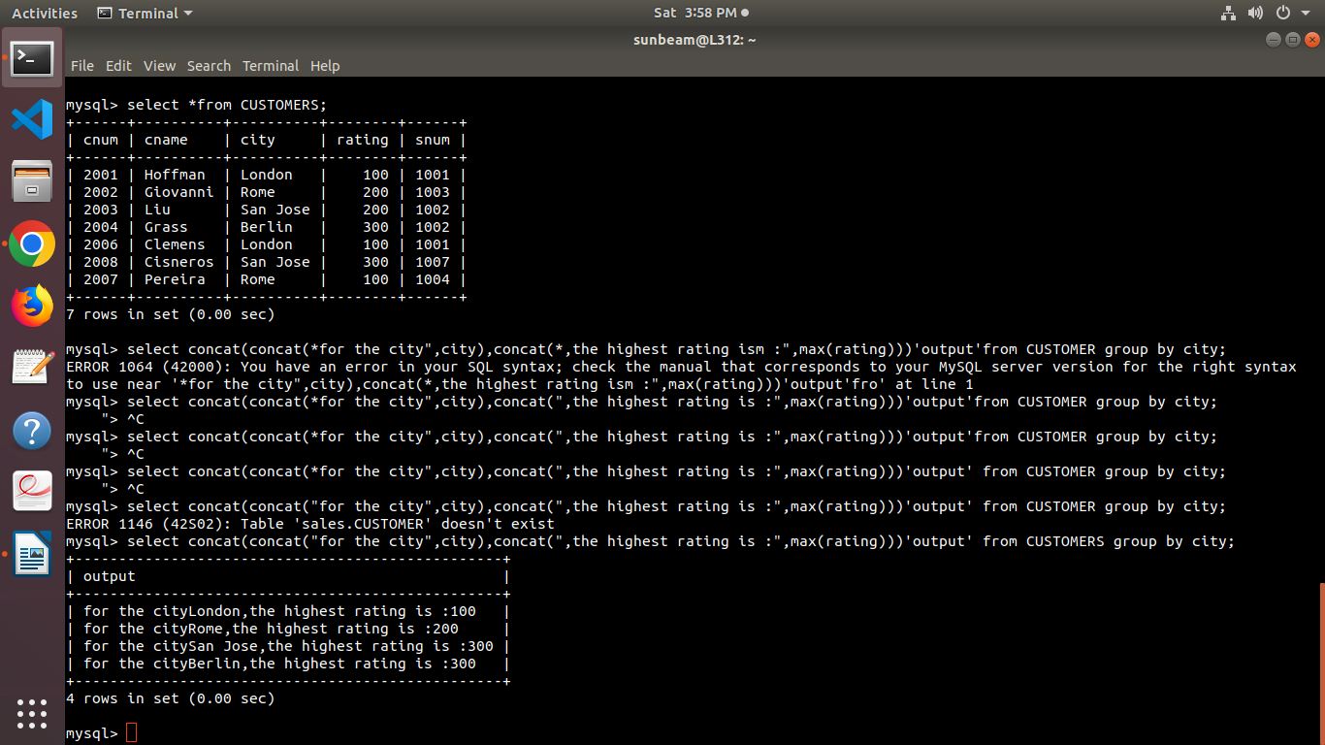
.

Q3) write a query that lists customers in descending order of rating .output the rating field first ,followed by the customer’s name and number ?
Solve-
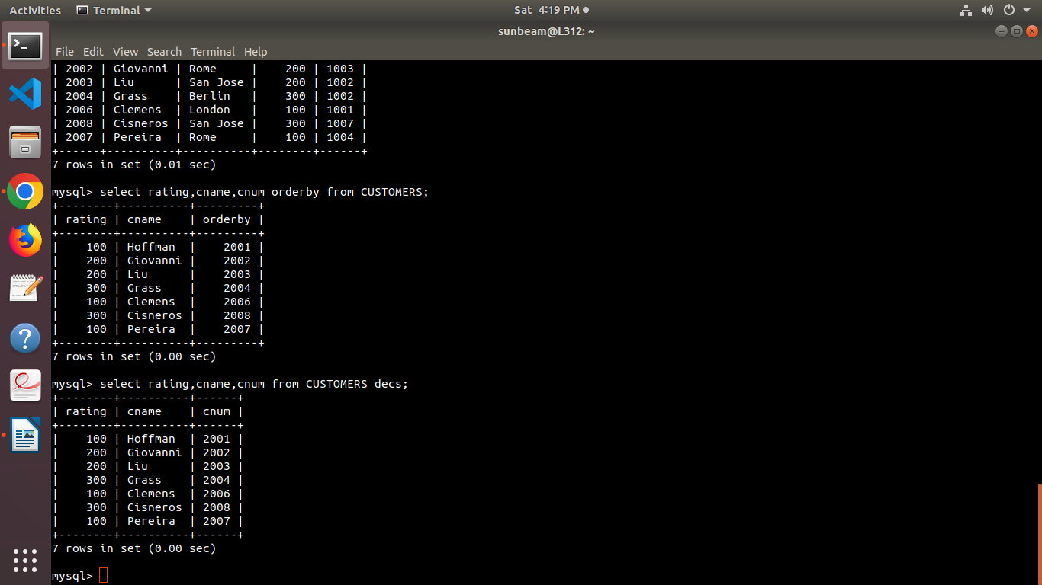

Q4) write a query that totals the orders for each day and places the results in descending order ?
Solve-

