MYSQL ASSIGNMENT-9

Q1) Write a query that lists each order number followed by the name of the customer who made the order.
Solve-

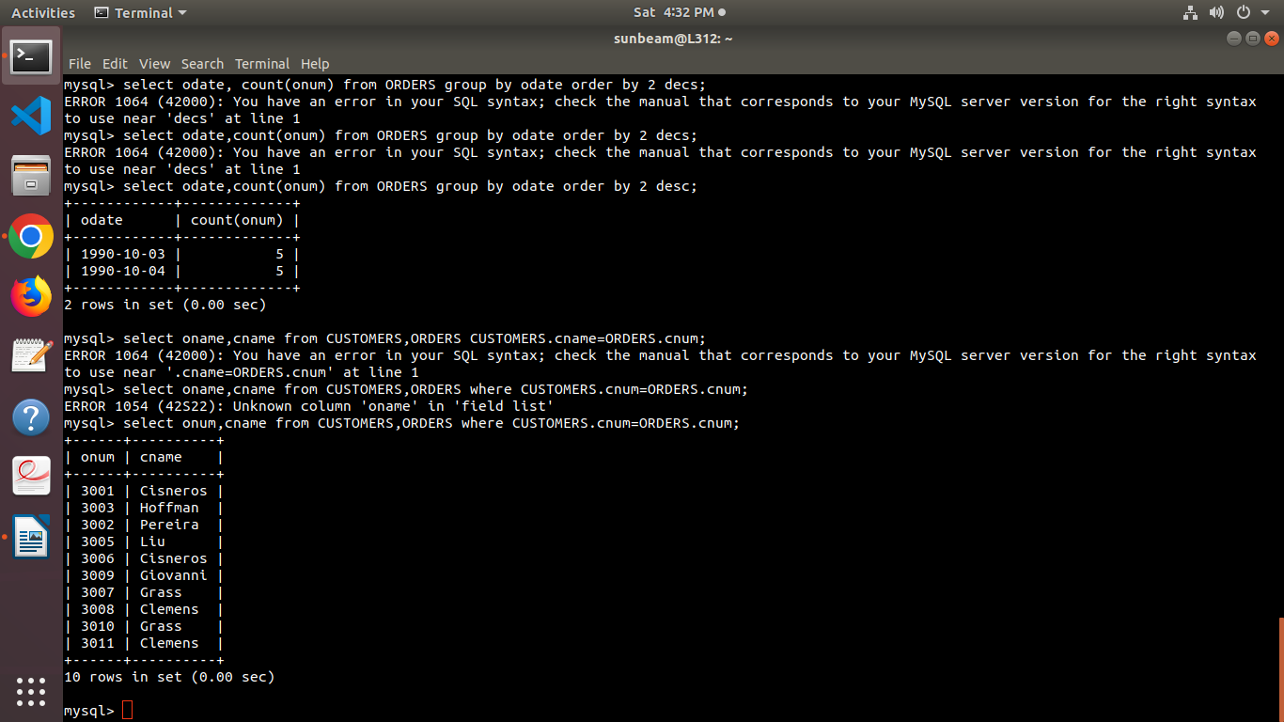

Q2) Write a query that gives the names of both the salesperson and the customer for each order along with the order number.
Solve
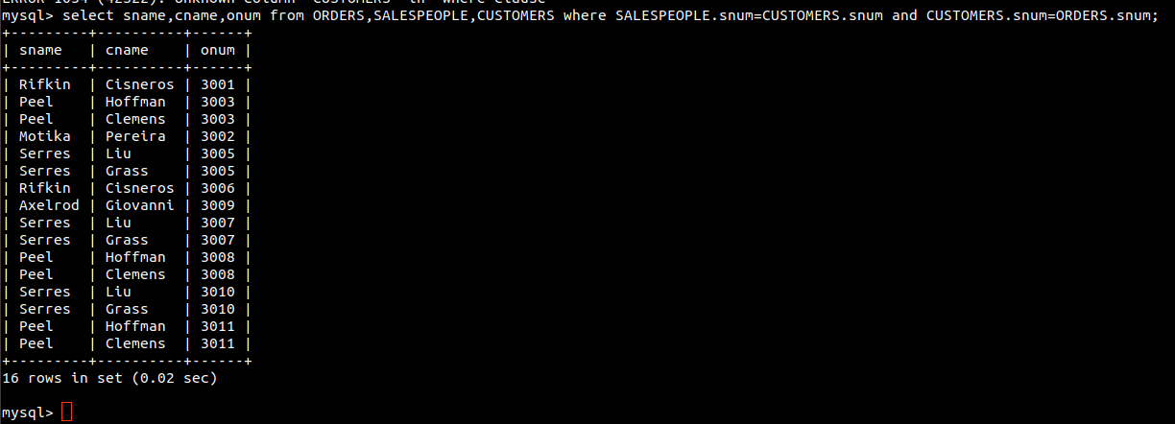

Q.3 Write a Query that produces all customers serviced by salespeople with a commission above 12%. output the customers name,the salesperson name, and the salespersons rate of commission

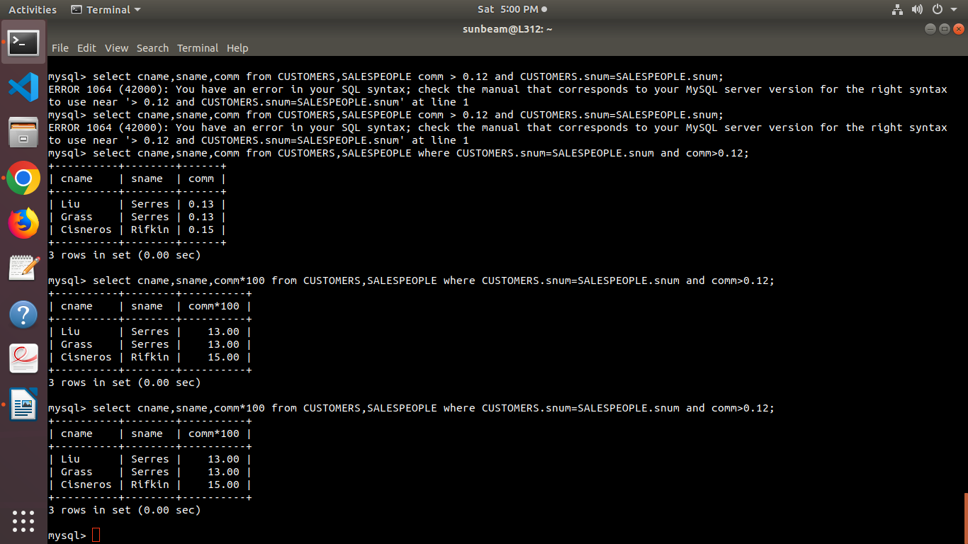

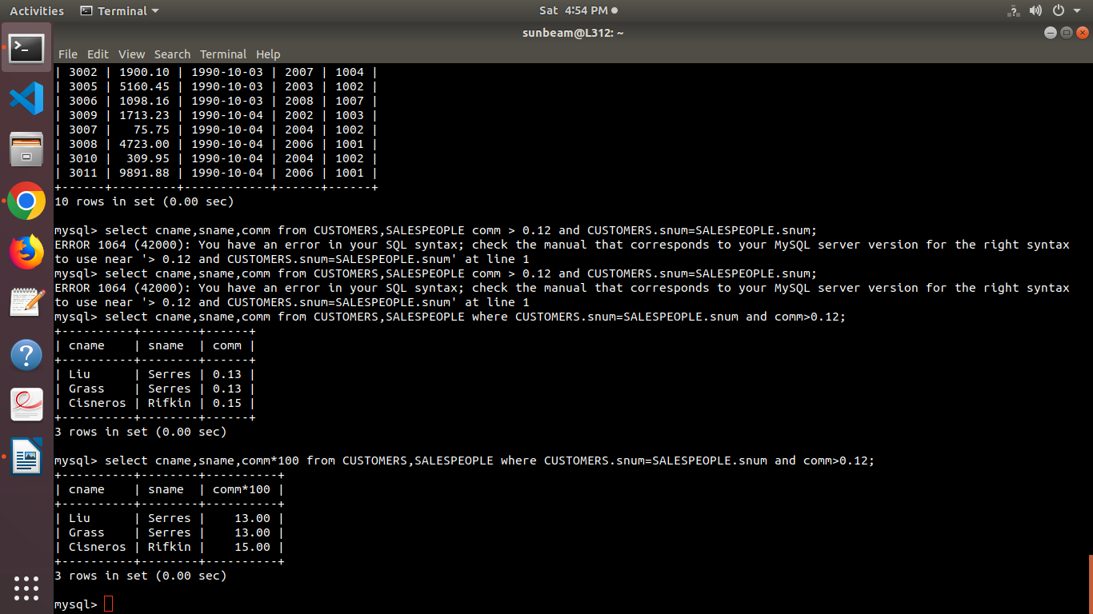
Q.4) Write a query that calculates the amount of the salespersons commission on each order by a customer with a rating above 100.

