MYSQL Assignment -11

Q1) Write a query that uses a subquery to obtain orders for the customer named cisneros .Assume you do not know his customer number (cnum).

solve-
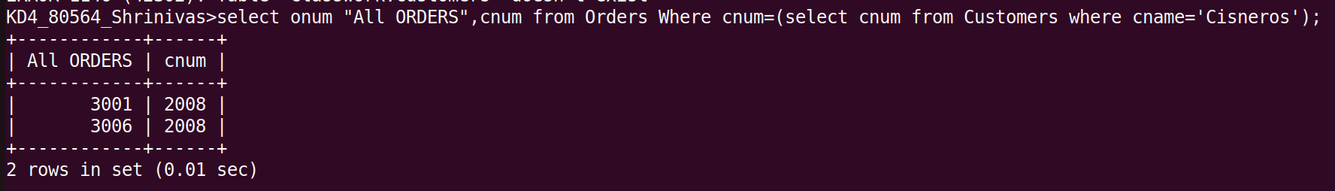

2) Write a query that produces the names and ratings of all customers who have
above-average orders.
solve-

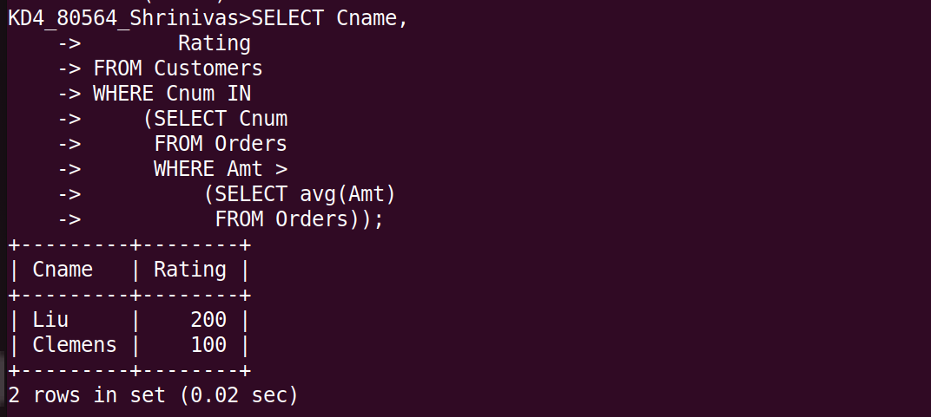

3) Write a query that selects the total amount in orders for each salesperson for
whom this total is greater than the amount of the largest order in the table.
