MYSQL Assignment -12

1) Write a query that selects all customers whose ratings are equal to or greater than
ANY of Serres’.
solve-

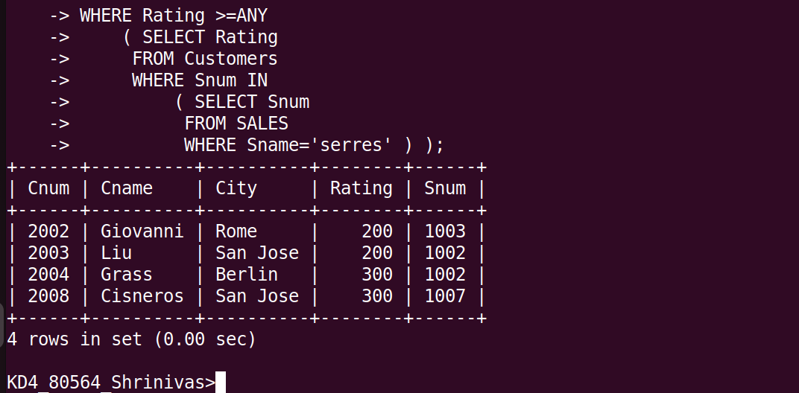

2) Write a query using ANY or ALL that will find all salespeople who have no
customers located in their city.
solve-
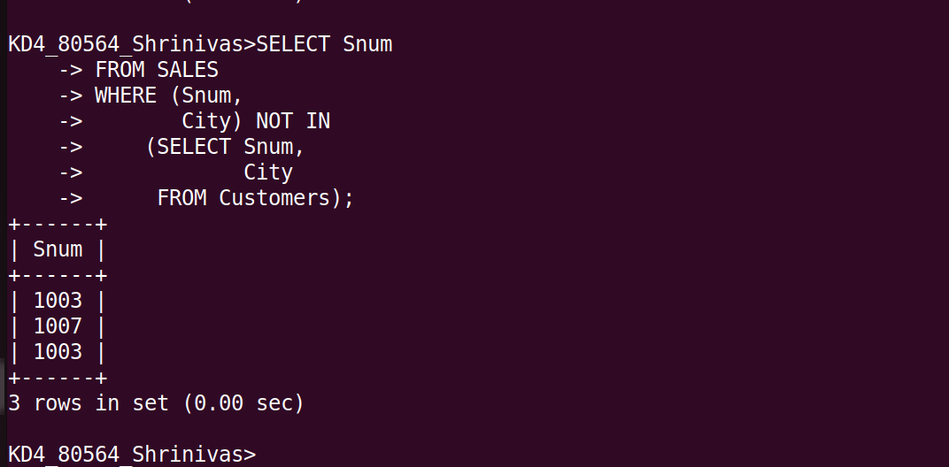

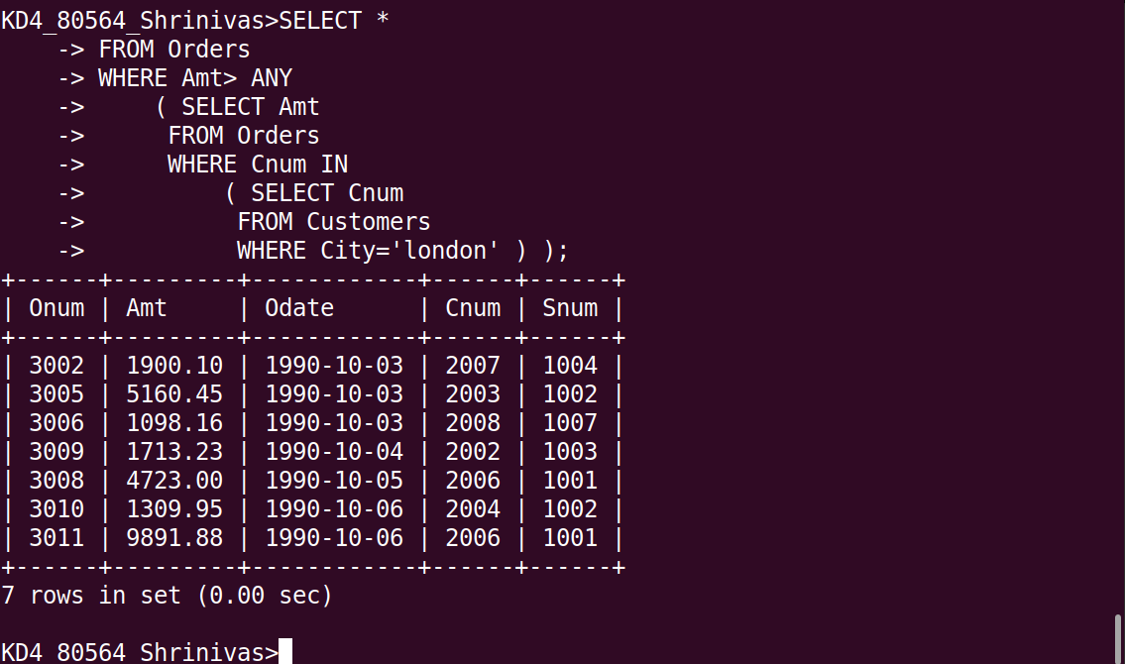
3) Write a query that selects all orders for amounts greater than any for the
customers in London.

4)Write the above query using MIN or MAX.

