MYSQL Assignment -7

Q1) Write a query that counts all orders for October 3.

solve-
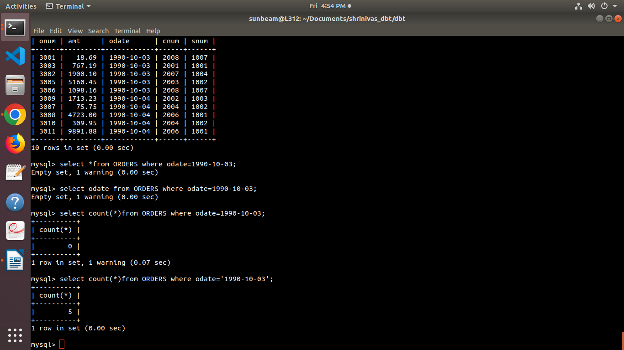

Q2) Write a query that counts the number of different non null city values in the Customers tabes
solve-

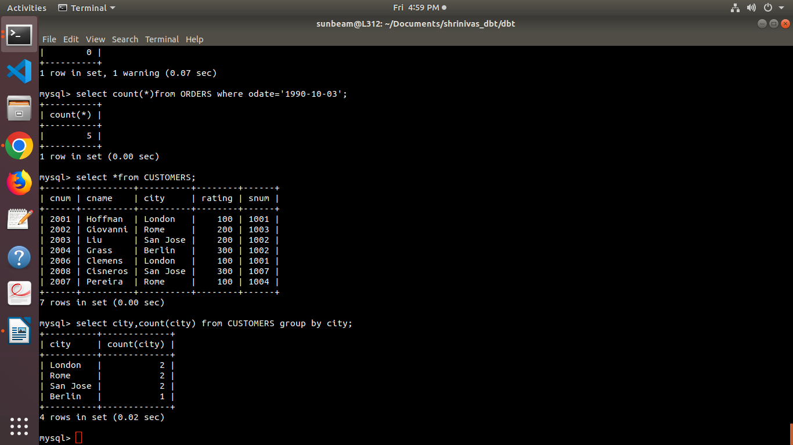

Q3) Write a query that select each customers’s smallest order ?
solve-
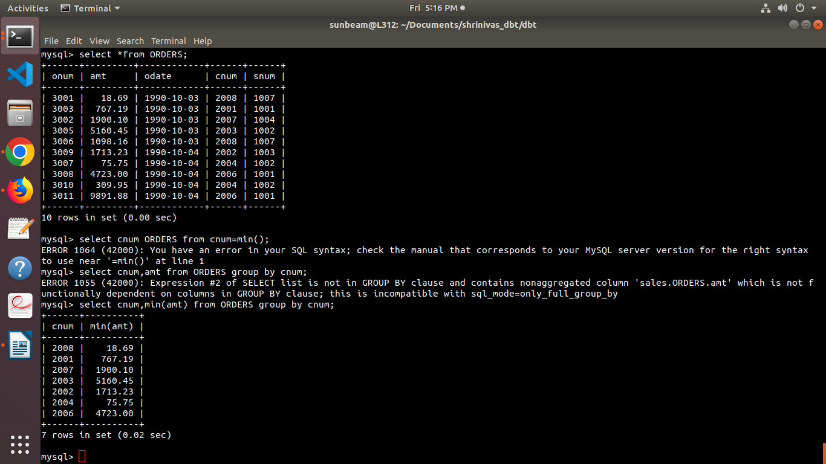

Q4) Write a Query that selects the first Customer in alphabetical order,whose name begins with G.
Solve -
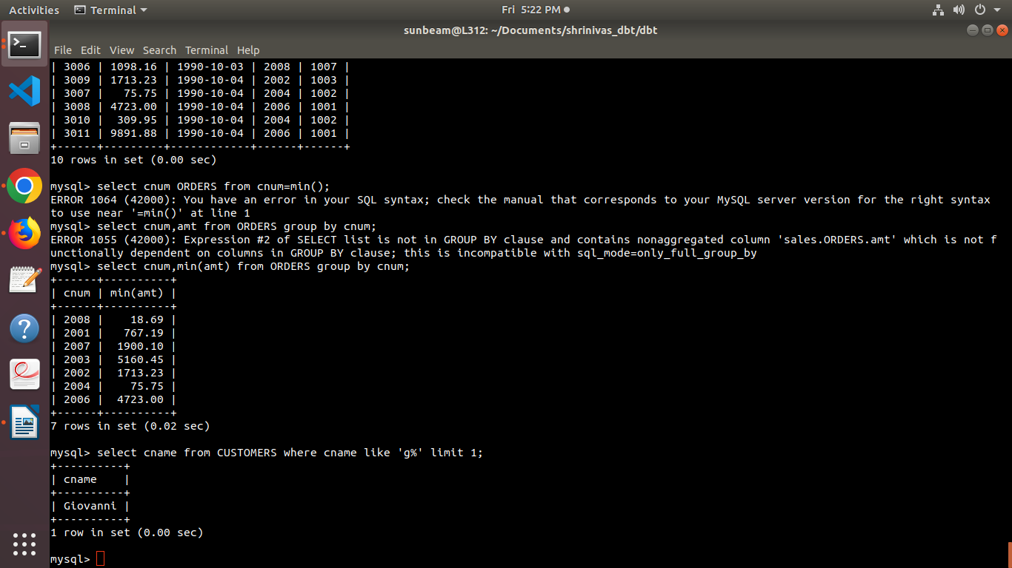

Q5) Write a Query that selects the highest rating in each city.
solve
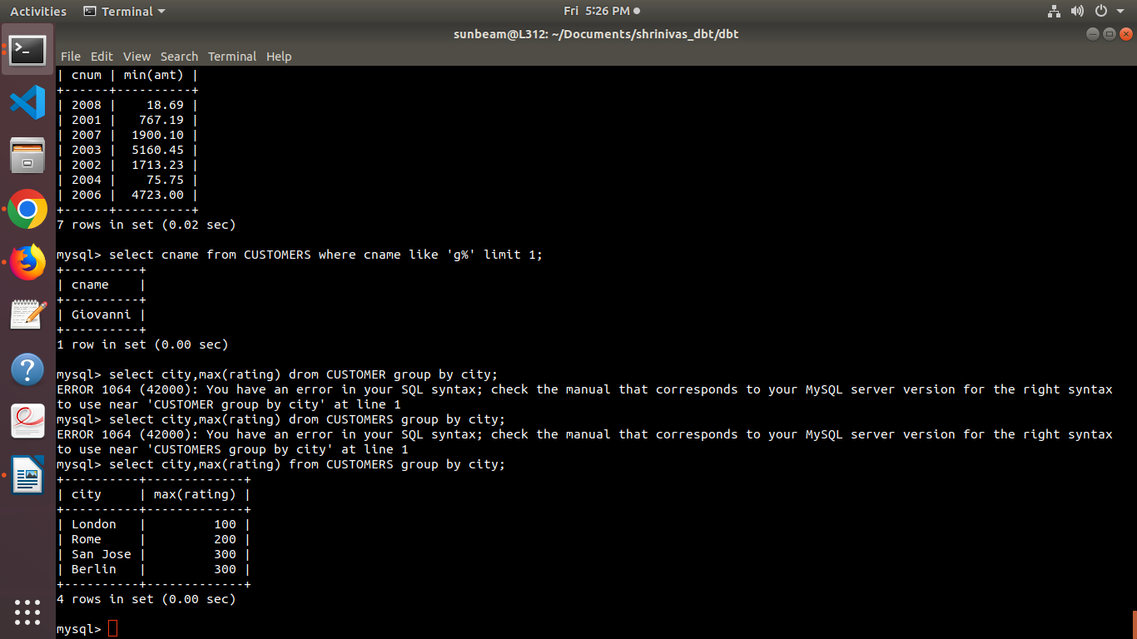

Q6) Write a Query that counts the number of Salespeople registering orders for each day . (if a salesperson has more than one order on a given day,he or she should be counted only once).
