ASSIGNMENT_11

1) Write a query that uses a subquery to obtain all orders for the customer named Cisneros. Assume you do not know his customer number(Cnum)
Ans:-

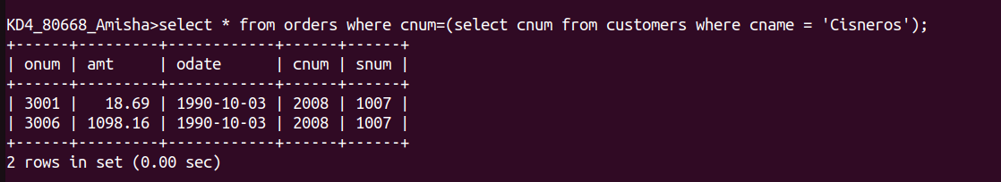

2) Write a query that produces the names and ratings of all customers who have above-average orders.
Ans:-

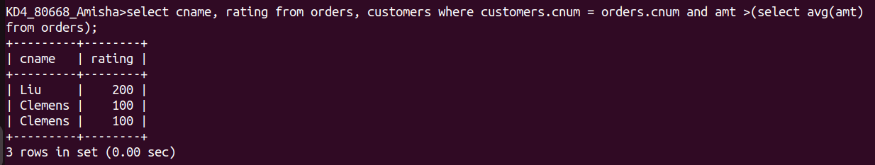
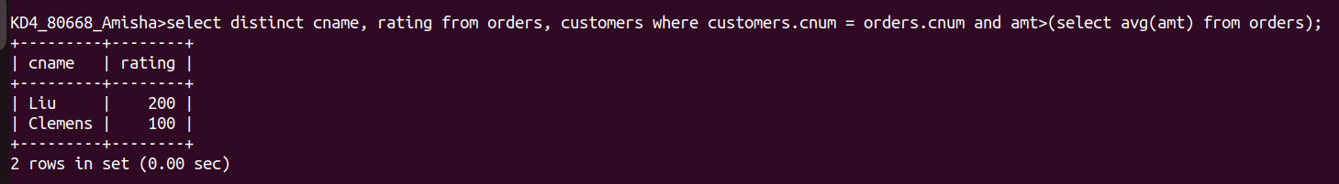

3) Write a query that selects the total amount in orders for each salesperson for whom this total is greater than the amount of the largest order in the table.
Ans:-

