ASSIGNMENT_01

Q. Create the following tables with given stuctures and insert sample data as specified:-
A) SALESPEOPLE
Snum int(4)
Sname vacchar(10)
City varchar(10)
Comm float(3,2)
Ans.
->Create table SALESPEOPLE
(Snum int(4),Sname varchar(10),City varchar(10),Comm float(3,2);
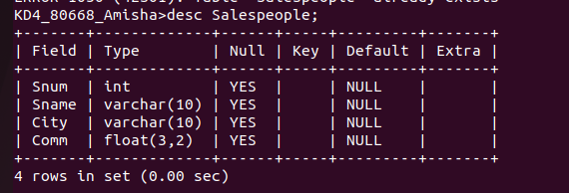
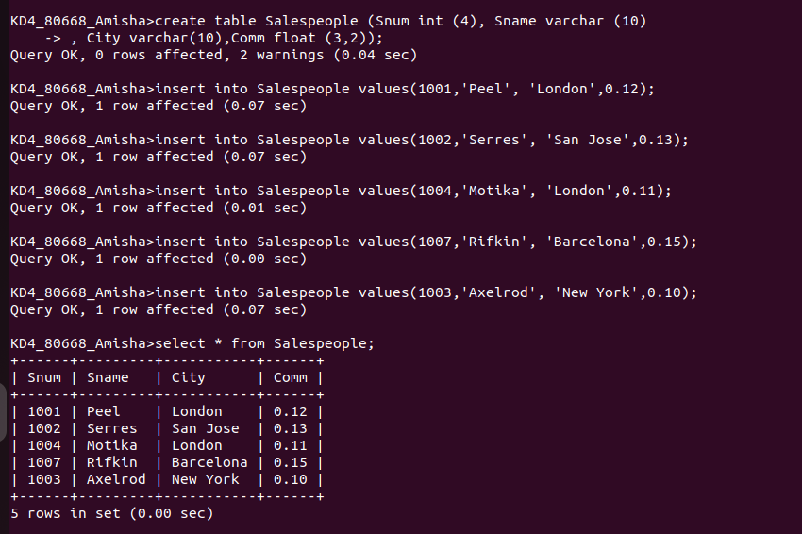
B) Customers
Cnum int(4)
Cname varchar(10)
City varchar(10)
Rating int(4)
Snum int(4)
Ans.
-> create table CUSTOMERS(Cnum int(4),Cname varchar(10),City varchar(10),Rating int(4),Snum int(4) );

-> insert into CUSTOMERS(Cnum,Cname,City,Rating,Snum) values(2001,'Hoffman','London',100,1001),(2002,'Giovanni','Rome',200,1003),(2003,'Liu','San Jose',200,1002),(2004,'Grass','Berlin',300,1002),(2006,'Clemens','London',100,1001),(2008,'Cisneros','san Jose',300,1007),(2007,'Pereira','Rome',100,1004);

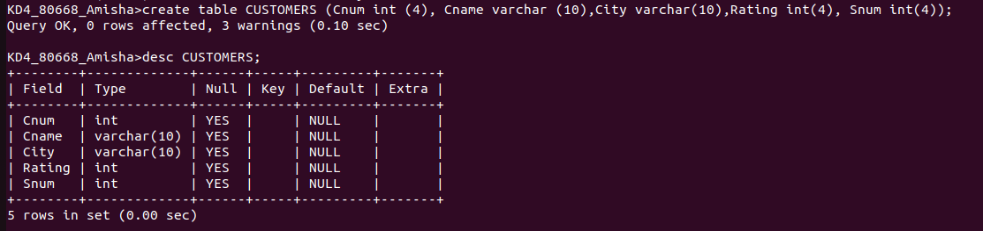

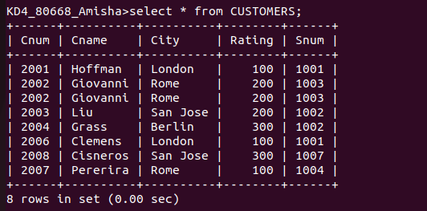

C) ORDERS
Onum int(4)
Amt float(7,2)
Odate date
Cnum int(4)
Snum int(4)

Ans.

