ASSIGNMENT – 5

Q.1 Write a query that will give you all orders for more than Rs. 1000.
Ans. Select * from ORDERS where Amt>1000;

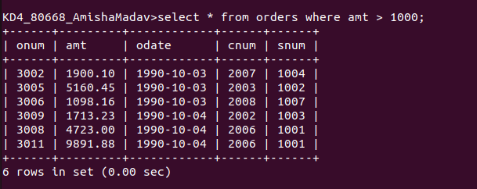

Q.2 Write a query that will give you the names and cities of all salespeople in London with a commision above .10.
Ans. Select sname, city from salespeople where City=’London’ and comm>.10;
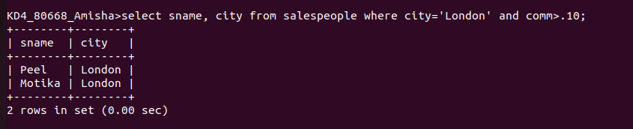
Q.3 Write a query on the Customers table whose output will exclude all customers with a Rating <= 100, unless they are located in Rome.
Ans. Select * from customers where Rating >= 100 or city=’Rome’;

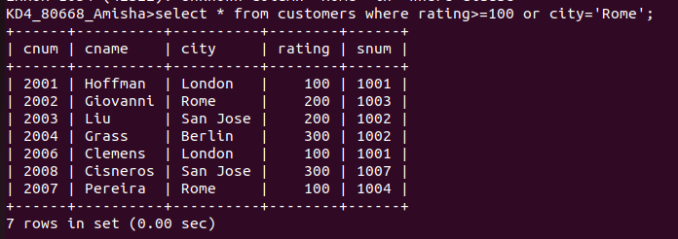

Q.4 What will be the output from the following query?
Select * from orders where (amt < 1000 OR NOT (Odate = ‘1990-10-03’ and cnum > 2003));

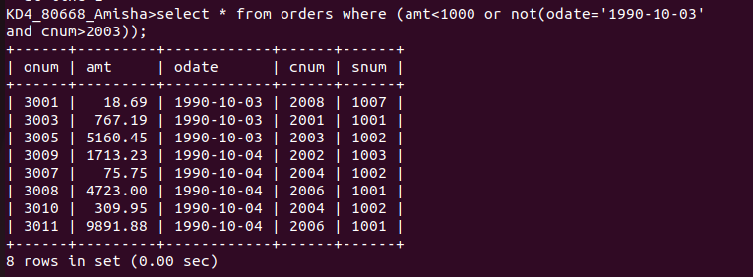

Q.5 What will be the output from the following query?
Select * from orders where NOT ( (odate = ‘1990-10-03’ OR snum > 1006) AND amt >= 1500);
Ans.

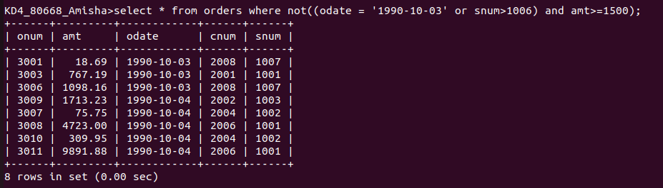

Q.6 What is the simpler way to write this query?
Select snum, sname, city, comm from Salespeople where (comm > .12 or comm < .14);
Ans. Select * from salespeople;

