ASSIGNMENT_06

Q.1 Write two different queries that would produce all orders taken on Octomber 3rd or 4th , 1990.

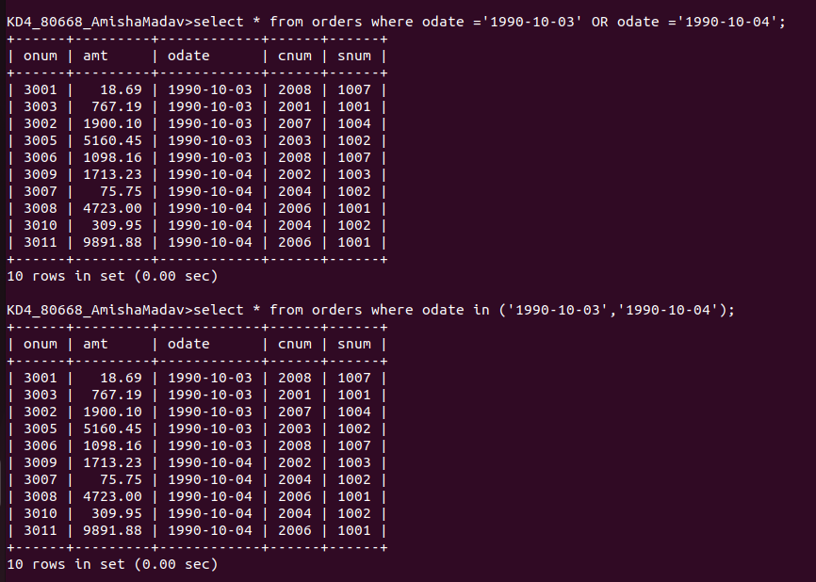

Q.2 Write a query that selects all of the customers serviced by Peel or Motika.
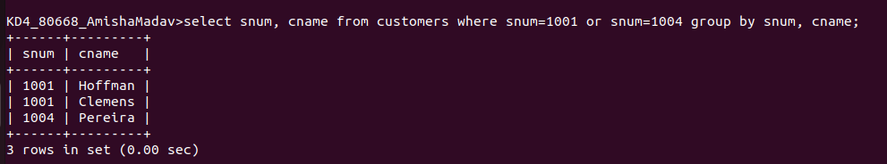

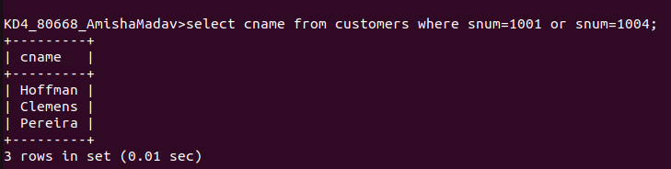

Q.3 Write a query that will produce all the customers whose names begin with a letter from ‘A’ to ‘G’.
Ans.
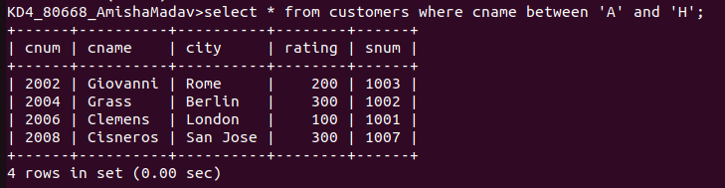

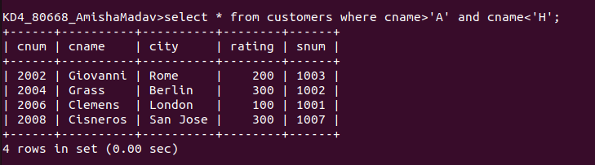

Q4. What a query that selects all customers whose names begin with the letter ‘C’.
Ans.

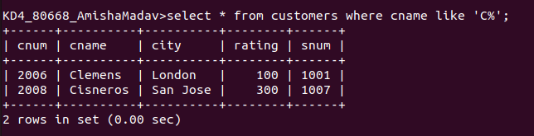

Q5. Write a query that selects all orders except those with zeroes or NULLs in the amt field.

