ASSIGNMENT_07

Q.1 Write a query that counts all orders for October 3.
Ans.
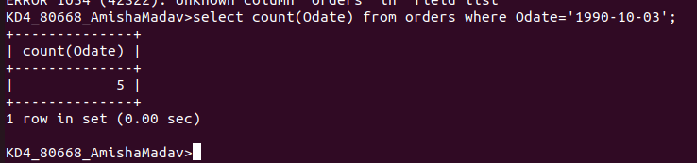

Q.2 Write a query that counts the number of different non-null city values in the customers table.
Ans.

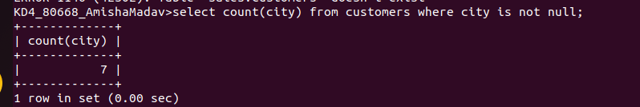

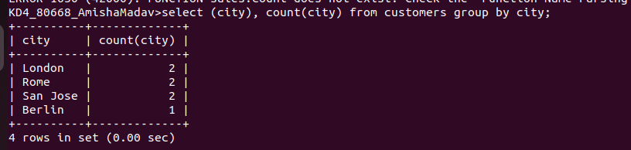

Q.3 Write a query that selects each customer’s smallest order.
Ans.

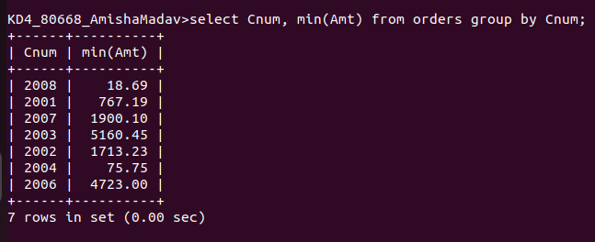

Q.4 Write a query that selects the first customer in alphabetical order, whose names bagins with g.
Ans.

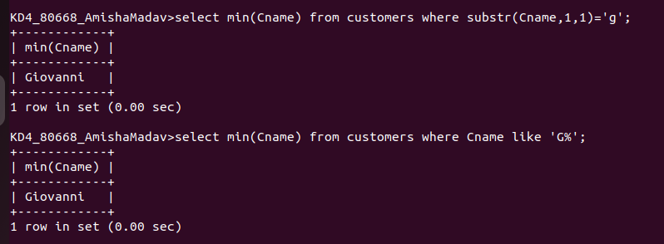

Q.5 Write a query that selects the highest rating in each city.
Ans:

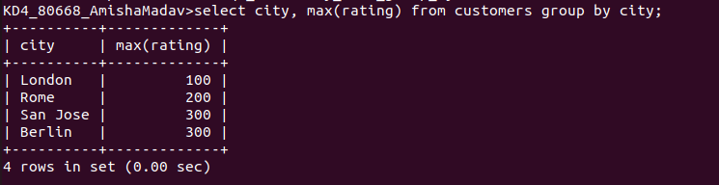

Q6. Write a query that counts the number of salespeople registering orders for each day. (If a salesperson has more than one order on a given day, he or she should be counted only once.
Ans.
