ASSIGNMENT_08

Q.1 Assume each salesperson has a 12% commision. Write a query on the orders table that will produce the order number , the salesperson number, and the amount of the salesperson’s commision for that order.
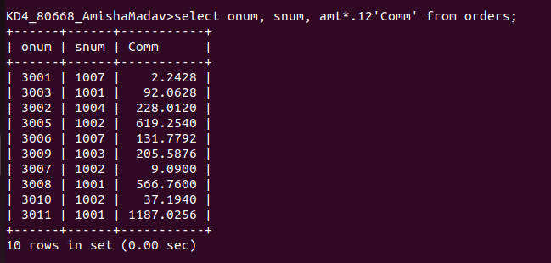

Q.2 Write a query on the Customers table that will find the highest rating in each city. Put the output in this form:
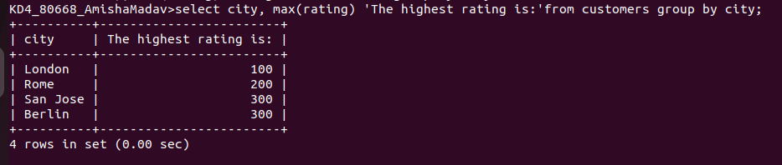
For the city (city), the highest rating is : (rating).
Q.3 Write a query that lists customers in descending order of rating. Output the rating field first, followed b the customer,s name and number.
Ans.
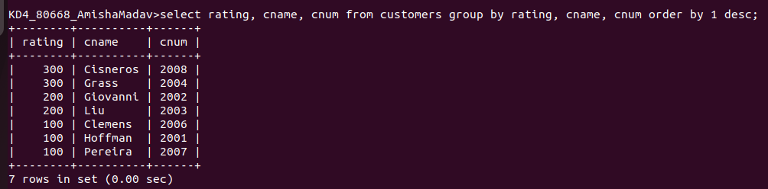

Q.4 Write a query that totals the orders for each day and places the results in descending order.
Ans.
