**Assignment-1**

**Question 1:-**

1. SALESPEOPLE

Snum int(4)

Sname varchar(10)

City varchar(10)

Comm float(3,2)

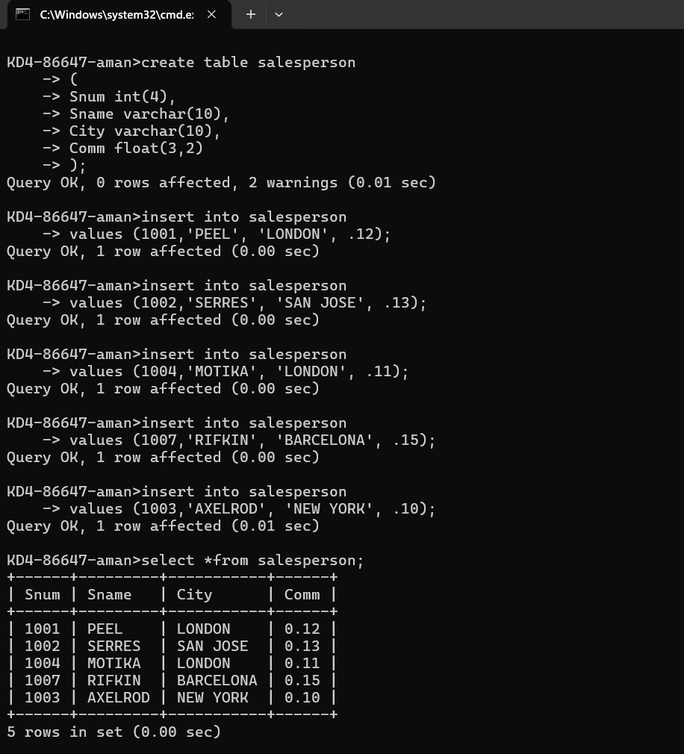

**Question 2:-**

B) CUSTOMERS

Cnum int(4)

Cname varchar(10)

City varchar(10)

Rating int(4)

Snum int(4)

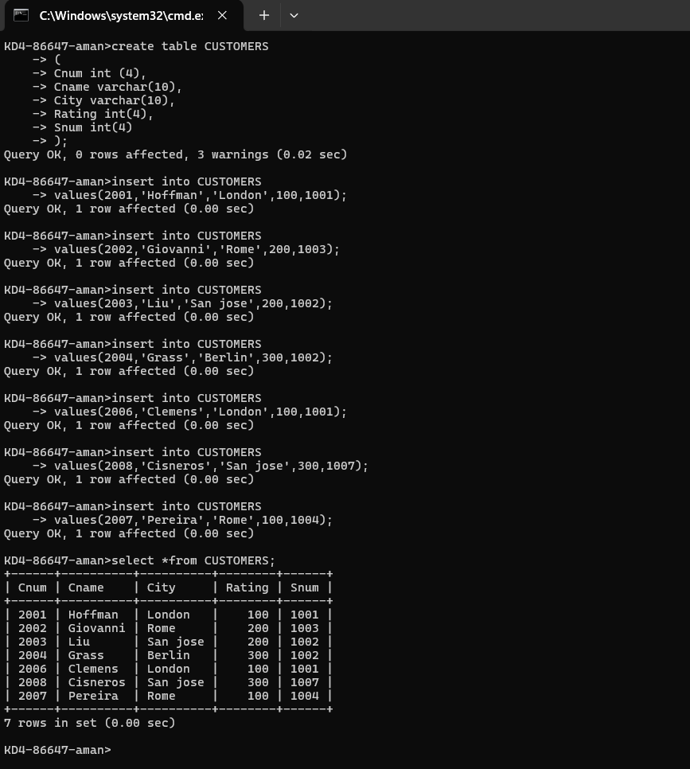

**Question 3:-**

1. ORDERS

Onum int(4)

Amt float(7,2)

Odate date

Cnum int(4)

Snum int(4)

