***Assignment – 15***

**Using Subqueries with DML Commands.**

1. Assume there is a table called Multicust, with all of the same column definitions as Salespeople. Write a command that inserts all salespeople with more than one customer into this table.

ANS : KD4-89208-Ashish>create table Multicast as

-> select * from salespeople

-> where snum IN

-> (Select snum

-> from customers

-> group by snum

-> having count(snum)>1);

Query OK, 2 rows affected, 1 warning (0.06 sec)

Records: 2 Duplicates: 0 Warnings: 1

KD4-89208-Ashish>select* from Multicast;

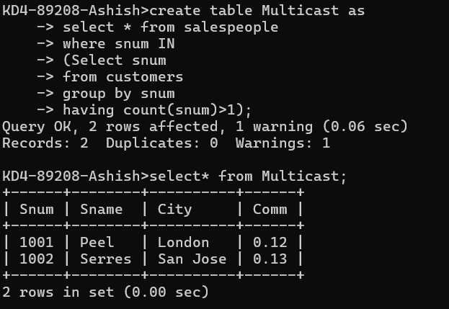

1. Write a command that deletes all customers with no current orders.

ANS : KD4-89208-Ashish>delete from customers

-> where cnum NOT IN (select cnum from orders);

Query OK, 1 row affected (0.02 sec)

KD4-89208-Ashish>select * from customers;

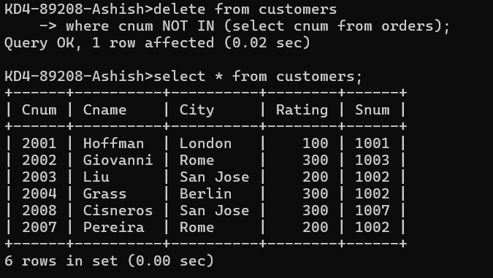

1. Write a command that increases by twenty percent the commissions of all salespeople with total orders above Rs. 3,000.

ANS: KD4-89208-Ashish>update salespeople

-> set comm = comm * 1.20

-> where snum in (select snum from orders

-> where amt >300);

Query OK, 5 rows affected (0.02 sec)

Rows matched: 5 Changed: 5 Warnings: 0

KD4-89208-Ashish>select * from salespeople;

