Assignment-5

Q1.Write a query that will give you all orders for more than Rs. 1,000.

ANS : KD4-89208-Ashish>select\*from ORDERS

-> where Amt>1000;

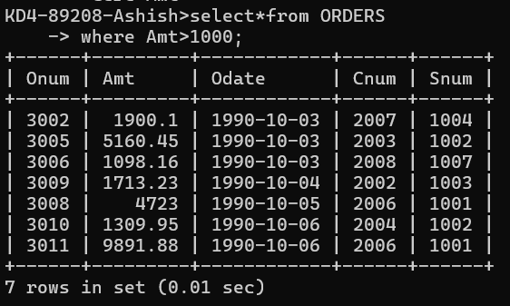

2) Write a query that will give you the names and cities of all salespeople in London with a commission above .10.

ANS : KD4-89208-Ashish>select Sname,City from SALESPEOPLE

-> where Comm>.10;

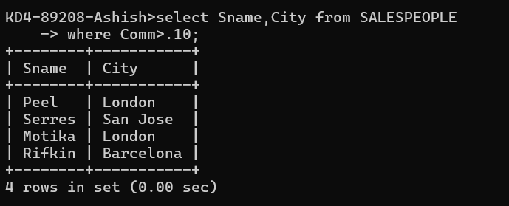

3) Write a query on the Customers table whose output will exclude all customers with a rating <= 100, unless they are located in Rome.

ANS : KD4-89208-Ashish>select\*from CUSTOMERS

-> where Rating>100 OR City='Rome';

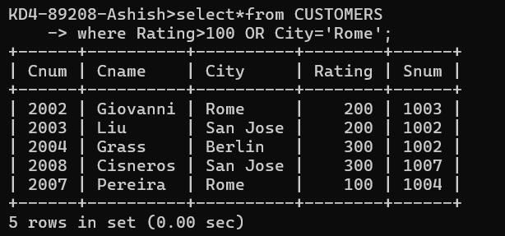

4) What will be the output from the following query?

ANS:Select \* from Orders

where (amt < 1000 OR

NOT (odate = ‘1990-10-03’

AND cnum > 2003));

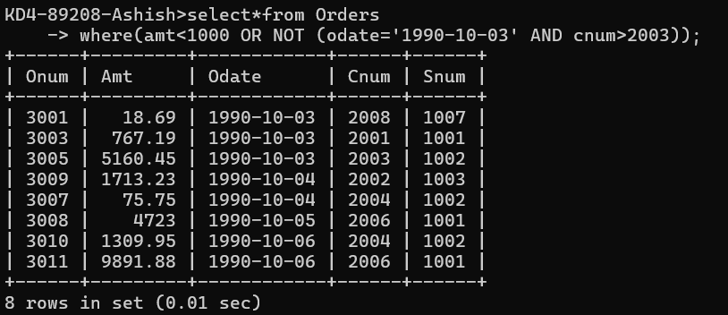

5) What will be the output of the following query?

Select \* from Orders

where NOT ((odate = ‘1990-10-03’ OR snum

>1006) AND amt >= 1500);

ANS: KD4-89208-Ashish>Select\*from Orders

-> where NOT((odate='1990-10-03'OR snum>1006)AND amt>=1500);

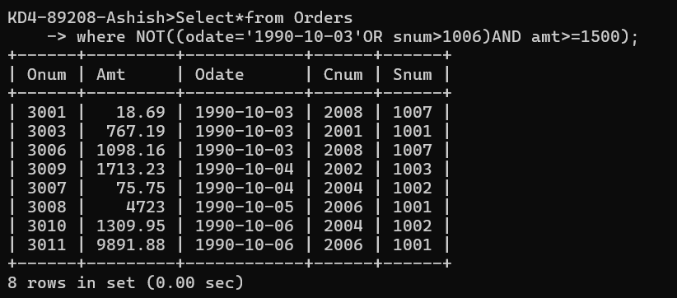

6) What is a simpler way to write this query?

Select snum, sname, city, comm From Salespeople where (comm > .12 OR comm <.14);

ANS= KD4-89208-Ashish>select\*from salespeople;

