1. Write a query that lists each order number followed by the name of the customer who made the order.

ANS :

KD4-89208-Ashish>select onum,cname from orders,customers

-> where customers.cnum=orders.cnum;

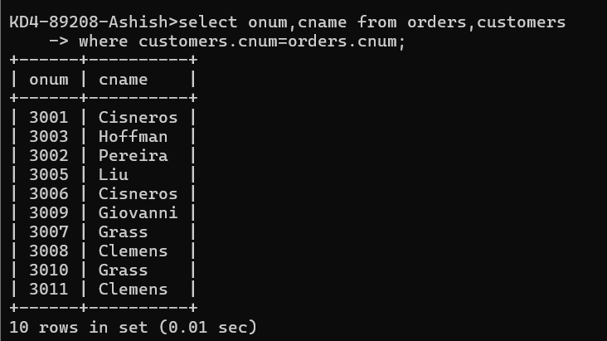

1. Write a query that gives the names of both the salesperson and the customer for each order along with the order number.

= KD4-89208-Ashish>select sname,cname,onum from orders,customers,salespeople -> where salespeople.snum=customers.snum and salespeople.snum=orders.snum

-> ;

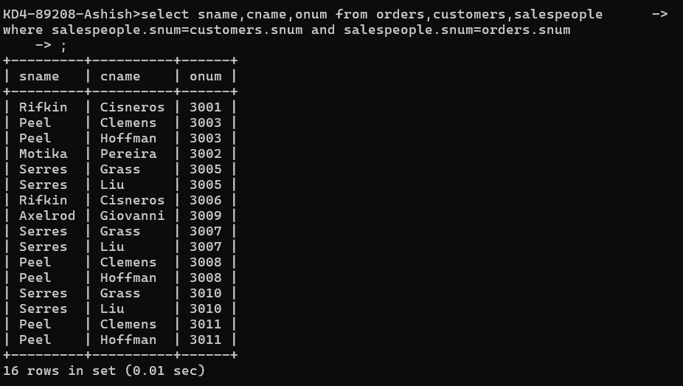

1. Write a query that produces all customers serviced by salespeople with a commission above 12%. Output the customer’s name, the salesperson’s name, and the salesperson’s rate of commission.

=

KD4-89208-Ashish>select cname,sname,comm from customers,salespeople

-> where salespeople.snum=customers.snum and salespeople.comm>.12;

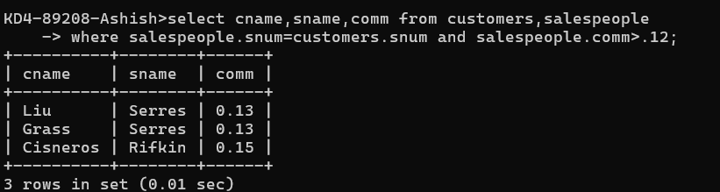

1. Write a query that calculates the amount of the salesperson’s commission on each order by a customer with a rating above 100.

= KD4-89208-Ashish>select amt\*comm,sname,rating from orders,customers,salespeople

-> where salespeople.snum=customers.snum and salespeople.snum=orders.snum

-> and rating > 100;

