MILO ALTAIR 8800 FPGA
Complete Gold Release Manual
Stage 7.5 / WRITE-FIX-3

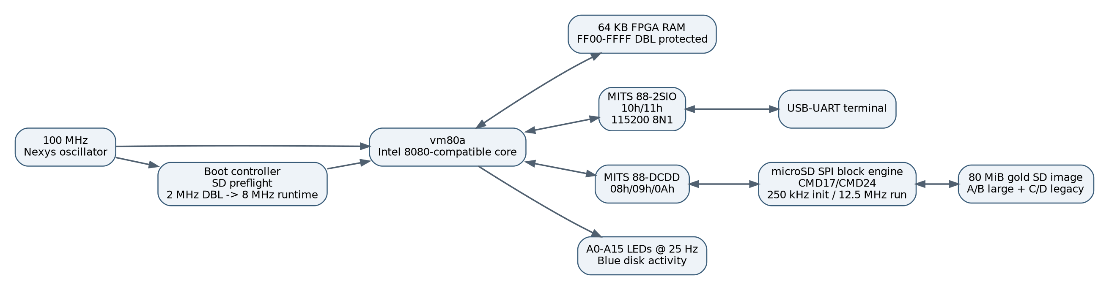
Target: Digilent Nexys A7-100T / XC7A100T-1CSG324C
Authentic 8080/CP-M appliance with persistent microSD storage and autonomous QSPI boot
Gold release date: 14 September 2026 | Manual rebuilt from exact pulled gold files: 19 September 2026

Contents
1. Gold release definition
2. Hardware and host requirements
3. System architecture
4. Boot and runtime behavior
5. Front panel and console
6. Memory and I/O map
7. Storage architecture
8. WRITE-FIX-3 deep dive
9. Preparing the microSD card
10. JTAG test and QSPI programming
11. Building from source
12. Gold validation procedure
13. Recovery
14. Troubleshooting
15. GitHub publication and licensing
Appendix A. Nexys A7 pin map
Appendix B. Implementation results
Appendix C. Gold hashes and file layout
This manual is intentionally source-driven. Where older notes disagree with the uploaded gold RTL or binary identity, the gold source and published SHA256 values take precedence.

1. Gold release definition
Stage 7.5 / WRITE-FIX-3 is the frozen production build of the MILO Altair 8800 FPGA appliance for the Nexys A7-100T. The release is defined by cryptographic identity rather than by filenames or timestamps.
Artifact | SHA256
altair_dcdd_sd.sv | 6765a46ece31864903d664d7952efc5c9e5678a16104a5322c85d07bd481fece
milo-altair8800-stage7-final.bit | 68deae429c52cf4711baa7ad417bd6970961beb3d8a0fd33cfeb9b28e52cc828
milo-altair8800-stage7-final-qspi-x4.mcs | c22c47d6fe426312d4dfd9e2d4916c74cbf9bbe0e39b05958ad3fd59006e3085
MILO-ALTAIR8800-STAGE7.5-WRITE-FIX-3.img | 34abb0d6c387f37304379c562c4abb5d5a563348677ea5aa34e44e5cbe6d42c7

What makes this release gold
- Authentic MITS DBL bootstrap path starts at 2 MHz.
- Runtime changes to a fixed 8 MHz only after real 88-2SIO transmit activity indicates CP/M is running.
- microSD writes are enabled and persistent.
- The A: boot region is preflight-read before CPU release; failure is fail-closed.
- WRITE-FIX-1/2/3 resolve the CP/M file close/directory persistence path.
- The final BIT and SPIx4 MCS were preserved and verified by SHA256 before this manual was generated.

Filename correction for the SD image
On MILO, the byte-for-byte gold 80 MiB image was still stored under the older filename MILO-ALTAIR8800-STAGE7.4-MAX-STORAGE.img. Its SHA256 exactly matched the Stage 7.5 gold image identity. This release renames the same bytes to MILO-ALTAIR8800-STAGE7.5-WRITE-FIX-3.img.

2. Hardware and host requirements
Item | Requirement
FPGA board | Digilent Nexys A7-100T, XC7A100T-1CSG324C
Storage | microSD card >= 80 MiB; normal modern cards are suitable
Console | Board USB-UART, 115200 8N1, no flow control
JTAG/QSPI | Board USB-JTAG connection; S25FL128S configuration flash
Known build host | Ubuntu 24.04.4 LTS
Known toolchain | AMD Vivado 2026.1
Fabric clock | 100 MHz board oscillator
The prebuilt BIT/MCS/SD image do not require a source rebuild. A rebuild is only needed when developing a new version or reproducing the implementation flow.

3. System architecture
The 100 MHz board oscillator is the only fabric clock. A phase accumulator generates 8080 phase enables. The vm80a CPU, 64 KB memory, 88-2SIO console, 88-DCDD disk shim, SD block engine, boot controller, and LED presentation logic all run in this synchronous fabric.

CPU and clocking
The CPU is the vm80a Intel 8080-compatible core. The gold top-level defines phase steps for nominal 2, 4, 8, 16, and 25 MHz modes, but Stage 7.5 production policy fixes runtime selection to 8 MHz. During DBL bootstrap, effective speed is forcibly 2 MHz regardless of the dormant selection infrastructure.

Memory
The design implements 64 KB of FPGA RAM. The initial RAM image is loaded from software/RAM_INIT.mem. CPU writes at FF00h-FFFFh are blocked, preserving the MITS DBL/PROM area.

Console
The MITS 88-2SIO-compatible interface occupies ports 10h/11h and drives the Nexys USB-UART at 115200 8N1.

Disk path
The MITS 88-DCDD-compatible interface occupies ports 08h/09h/0Ah. Each 137-byte physical Altair sector maps to a 512-byte SD block. SD initialization uses approximately 250 kHz SPI; normal transfers use approximately 12.5 MHz.

4. Boot and runtime behavior
The production boot controller deliberately bypasses the older persistent setup state. LBA 64 remains reserved in the source, and the menu implementation remains present, but the Stage 7.5 active state path forces speed selection 8 MHz, write protection off, and transitions directly into A: preflight.
Firmware : Stage 7.5 / FIXED 8 MHz PRODUCTION
Console : MITS 88-2SIO @ 115200 8N1
Profile : AUTO BOOT / SD WRITES ENABLED
If SD initialization fails or the A: preflight cannot read LBA 2048, DBL is not released into a blind hang. The controller prints a diagnostic and holds the CPU reset path.

5. Front panel and console

Address LEDs
The 16 red board LEDs sample the real A0-A15 address bus every 4,000,000 cycles of the 100 MHz fabric clock, producing a 25 Hz human-visible display. The final gold RTL assigns this sampled bus directly to LED[15:0]. It is not inverted.

Disk activity
RGB LED16 blue is asserted for roughly 75 ms whenever low-level SD activity or an access to a DCDD port occurs. Red and green channels are held off.

Seven-segment display
All segment and anode outputs are driven inactive. The seven-segment display is intentionally dark.

Serial terminal
- 115200 baud
- 8 data bits
- no parity
- 1 stop bit
- no hardware/software flow control

6. Memory and I/O map
Address/Port | Function | Notes
0000h-FEFFh | RAM | writable 64 KB memory except protected top page
FF00h-FFFFh | DBL/PROM region | reads from initialized memory; CPU writes blocked
08h | DCDD drive select / inverted status | select/disable drive; status read
09h | DCDD drive control / sector position | STEP, head load/unload, sector timing, write enable
0Ah | DCDD raw sector data | 134/137-byte write behavior by track region
10h | 88-2SIO control/status | receive/transmit status and control
11h | 88-2SIO data | UART data register
FFh | Sense switch value | gold top-level returns 10h

7. Storage architecture
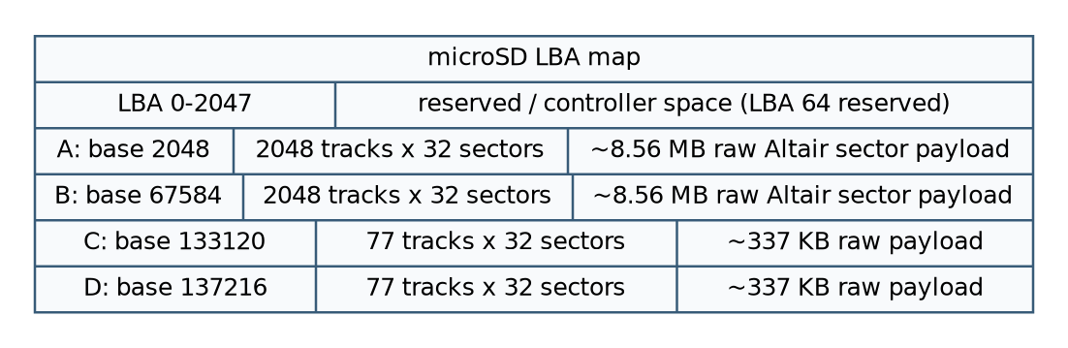
The one-sector-per-LBA mapping consumes more microSD address space than the Altair payload itself, but it avoids packing/unpacking complexity and makes the DCDD emulation deterministic.
Drive | Base LBA | Tracks | Sectors/track | Altair payload bytes | Role
A: | 2048 | 2048 | 32 | 8,978,432 | SYSTEM
B: | 67,584 | 2048 | 32 | 8,978,432 | PROGRAMMING
C: | 133,120 | 77 | 32 | 337,568 | GAMES
D: | 137,216 | 77 | 32 | 337,568 | WORK
System-format tracks 0-5 use the shorter physical write threshold described in WRITE-FIX-3. The controller also keeps embedded boot material in FPGA block RAM for deterministic startup behavior.

8. WRITE-FIX-3 deep dive

WRITE-FIX-1 - asynchronous SD commit race
CMD24 can still be committing after the emulated 137-byte media transfer is logically finished. The final logic allows safe mechanical commands such as STEP/head operations during that in-flight commit. It blocks only a new write-enable/data phase that would conflict with the busy SD block buffer.

WRITE-FIX-2 - writable filesystem region
Earlier variants treated too much of the beginning of A: as immutable. The gold active path restricts embedded boot handling to the actual boot tracks, allowing normal CP/M directory/filesystem writes to reach SD-backed tracks.

WRITE-FIX-3 - exact write lengths
write_bytes_expected = (track < 6) ? 134 : 137;
This matches the BIOS behavior on system-format versus normal data tracks. A directory update on a system-format track no longer waits for three bytes that the BIOS never sends, so the SD commit launches and the CP/M CLOSE operation can complete.

Why this matters
A raw data path can appear healthy while normal CP/M file semantics still fail. PIP and ED exercise create, write, directory update, close, and subsequent readback; those operations are the meaningful gold validation.

9. Preparing the microSD card
The gold image is exactly 80 MiB (83,886,080 bytes). Use the release image whose SHA256 is published in the gold table. Do not rely on an old filename.
sudo ./tools/write-gold-sd.sh /dev/sdX
The new release helper writes exactly 20 x 4 MiB and hashes the complete 80 MiB region back from the device. This supersedes older helper behavior intended for earlier 16 MiB images.

Safety rules
- Use a whole-disk device, not a partition.
- Confirm the model/capacity shown before typing the destructive confirmation.
- Never target the running system disk.
- Require full-region SHA256 readback before calling the card good.

10. JTAG test and QSPI programming

JTAG first
Load the gold BIT temporarily and prove the complete boot/write path before touching permanent configuration flash.
./tools/jtag-load-gold.sh
The success marker from the original Tcl flow is STAGE7_JTAG_LOAD=PASS.

QSPI programming
./tools/flash-gold-qspi.sh
The original flash script requires exactly one XC7A100T, selects the S25FL128S configuration-memory definition, creates the indirect programming bitstream, and enables erase/program/verify. Do not interrupt the operation; wait for STAGE7_QSPI_FLASH_VERIFY=PASS.

11. Building from source
The exact source tree is included, but three $readmemh statements use the original absolute development path /home/milo/fpga/mits-altair8800/software/. For an exact-source reproduction attempt, place the repo at ~/fpga/mits-altair8800 rather than editing those lines.
source /data/fpga/AMD/2026.1/Vivado/settings64.sh
vivado -mode batch -source stage7/build/build.tcl
The build script fails closed on negative timing slack. A successful rebuild is a candidate, not automatically the historical gold binary. Compare hashes and hardware-validate any changed output.

12. Gold validation procedure
1. Run gold hash verification.
2. Write and fully readback-verify the 80 MiB SD image.
3. JTAG-load the gold BIT.
4. Confirm the Stage 7.5 fixed-production UART banner.
5. Confirm boot precheck PASS and authentic 2 MHz DBL start.
6. Confirm CP/M reaches A0> under fixed 8 MHz runtime.
7. Create/close/read a file using PIP.
8. Create/save/read a file using ED.
9. Reset/cold boot and confirm persistence.
10. Program and verify the gold QSPI MCS.
11. Cold boot without JTAG loading and repeat persistence verification.

13. Recovery
Recovery should move from least invasive to most invasive. First verify hashes; second rewrite the SD image; third JTAG-load the known-good BIT; only after that should QSPI be reprogrammed. The outer release bundle preserves the original pulled master ZIP unchanged so packaging mistakes cannot destroy the source-of-truth snapshot.

14. Troubleshooting
Symptom | Likely first action
No banner | Verify UART connection/settings and board reset/power.
SD init error | Reseat card; rewrite gold image; verify full 80 MiB.
Boot precheck fails | Verify exact SD hash and readable A: base LBA 2048.
PIP cannot close file | Verify gold DCDD RTL/BIT/MCS hashes; do not use pre-fix binaries.
File disappears after reboot | Confirm the card, not a stale image/file, received the write and passed readback.
JTAG is correct but cold boot is old | QSPI flash was not successfully programmed/verified.
Rebuild hash differs | Treat output as a new candidate; do not overwrite gold artifacts.
A field note from the gold validation record: if the address LEDs remain static and a cold boot appears stuck, retry reset/power-cycle before assuming the storage or QSPI must be rewritten.

15. GitHub publication and licensing
This release bundle is organized for GitHub, but technical completeness does not settle redistribution rights. The vm80a source explicitly carries CC BY 3.0. Historical CP/M, MITS-style boot media, software images, and derived prebuilt artifacts require provenance review before public redistribution. The repository therefore includes a license notice rather than inventing a blanket license.
- Keep the four gold hash identities immutable.
- Do not commit the outer Master-Archive automatically to a public repository.
- Preserve upstream notices in source files.
- Select an explicit license for original MILO project work before inviting external reuse.
- If third-party software rights are unresolved, publish HDL/docs separately from software/media.

Appendix A. Nexys A7 pin map
Signal | Pin | Use
CLK100MHZ | E3 | 100 MHz oscillator
CPU_RESETN | C12 | active-low reset
UART_RXD_OUT | C4 | PC -> FPGA
UART_TXD_IN | D4 | FPGA -> PC
LED[0..15] | H17,K15,J13,N14,R18,V17,U17,U16,V16,T15,U14,T16,V15,V14,V12,V11 | sampled A0-A15
LED16_B | R12 | disk activity
SD_RESET | E2 | held low
SD_CD | A1 | card detect
SD_SCK | B1 | SPI SCK
SD_CMD | C1 | SPI MOSI
SD_DAT0 | C2 | SPI MISO
SD_DAT3 | D2 | SPI CS

Appendix B. Implementation results
Resource | Used | Available | Utilization
Slice LUTs | 8,436 | 63,400 | 13.31%
Slice registers | 5,253 | 126,800 | 4.14%
Block RAM tiles | 25 | 135 | 18.52%
DSPs | 1 | 240 | 0.42%
Bonded I/O | 46 | 210 | 21.90%
BUFGCTRL | 1 | 32 | 3.13%
Routed timing summary: 100.000 MHz system clock, WNS +0.406 ns, TNS 0.000 ns, zero failing endpoints. All user-specified timing constraints are reported as met.
The DRC report contains warnings rather than errors, including missing CFGBVS/CONFIG_VOLTAGE properties, DSP pipelining suggestions, and incomplete bidirectional buffering warnings on SD_DAT. These warnings are preserved in reports/stage7-drc.txt and did not prevent the validated gold implementation.

Appendix C. Gold hashes and file layout
6765a46ece31864903d664d7952efc5c9e5678a16104a5322c85d07bd481fece stage7/src/altair_dcdd_sd.sv
68deae429c52cf4711baa7ad417bd6970961beb3d8a0fd33cfeb9b28e52cc828 release/milo-altair8800-stage7-final.bit
c22c47d6fe426312d4dfd9e2d4916c74cbf9bbe0e39b05958ad3fd59006e3085 release/milo-altair8800-stage7-final-qspi-x4.mcs
34abb0d6c387f37304379c562c4abb5d5a563348677ea5aa34e44e5cbe6d42c7 release/MILO-ALTAIR8800-STAGE7.5-WRITE-FIX-3.img
Key repository directories:
- stage7/src - exact active gold RTL and XDC only.
- stage7/build - original Vivado build/JTAG/QSPI Tcl scripts.
- software - exact memory-init inputs required by active RTL plus authentic DBL reference files.
- release - gold BIT, SPIx4 MCS, and 80 MiB SD image.
- reports - original routed timing, DRC, and utilization reports.
- tools - safer release verification/write/program wrappers.
- provenance - original pull environment/manifests.
- docs - this manual and focused reference guides.

