Kirk Allgeyer

06/09/2021

CIS 420

Dr.Fuller

**CIS420 Practical Final Exam**

**Problem 1: Use case and requirements**

The following is an example use case diagram for this Exercise. Note that all the use cases specifically requested relate to the Line Supervisor actor. Some additional use cases have also been included in the diagram that relate to other actors. These are either described or implied in the interview transcript, but use case descriptions are not given here. Generate use case descriptions for the use cases listed in the Production Line Control boundary.

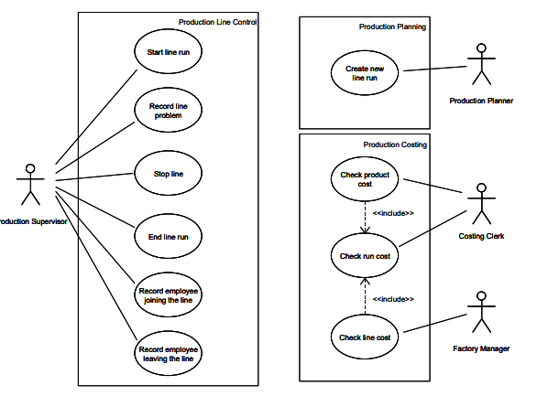

In the Product Line Control boundary, there are relationships with the Production Supervisor and Employees entering and leaving the line.

1. The Production Supervisor begins the line run.
2. The Production Supervisor records the problem on the line.
3. The Production Supervisor stops the line to assess a solution to a perceived problem.
4. The Production Supervisor ends the line run for this inspection.
5. The Production Supervisor records the employee joining the line.
6. The Production Supervisor records the employee leaving the line.

**Problem 2: Object Modeling**

Draw a domain model to fit the following description in the space at the bottom of this sheet.

**Hint**: use a pencil and an eraser. Or a black/white board with chalk. Draw incomplete boxes.

**Vision -- Depot Stock Control Software**

Software runs in a depot that ships stocks requested by orders. It helps the depot manager manage stock levels and outstanding orders.

**Use Case UC1 Manager reviews unfulfilled orders**

The manager at a depot logs in and sees a list of the sales orders that his depot has not yet fulfilled.

**Part A**

Your diagram should show the following information (and not much else!).

**Classes**

1. Depot, Product, Stock, Customer, Sales Order, Sales Item

**Associations**

* 1. A Depot holds Stocks.
  2. Products are stocked as Stocks.
  3. A Depot has Customers.
  4. A Customer can have Sales Orders.
  5. A Sales Order has Sales Items.
  6. A Stock can be ordered as a Sales Item

**Multiplicities**

* 1. Each Stock has precisely one Product and is held at one Depot.
  2. Each Customer is served by only one depot.
  3. Each Sales Item is on one Sales Order and is for one Stock.

**Part B**

**Attributes**

* 1. Depot: Id and address,
  2. Customer: name and address,
  3. Sales order: dateOrdered, dueDate,
  4. Sales Item: price and quantity,
  5. Product: description and units.

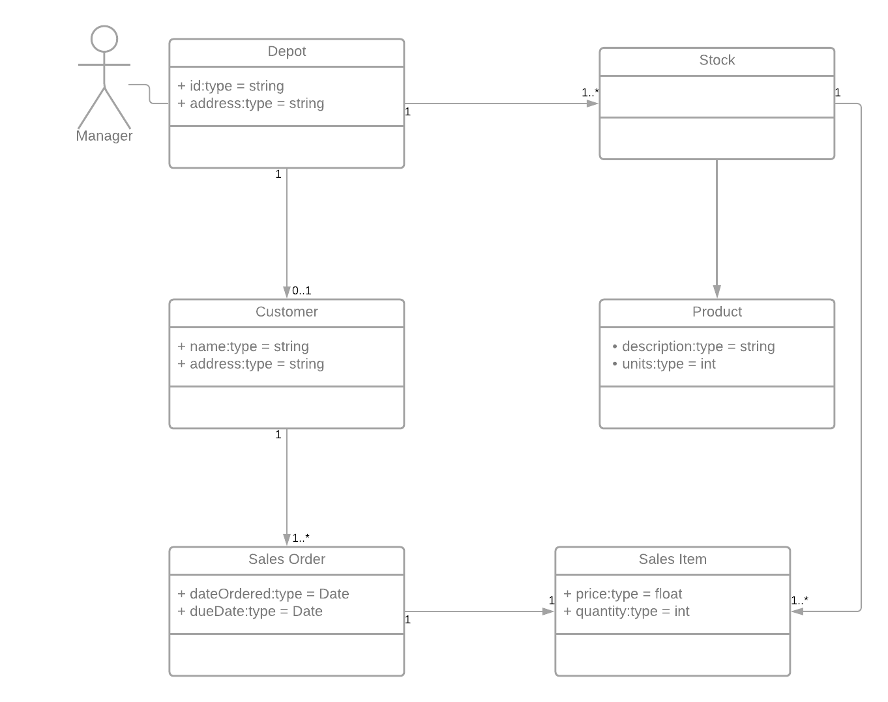

**Problem 3: Implementation**

Answer the following questions about the class diagram

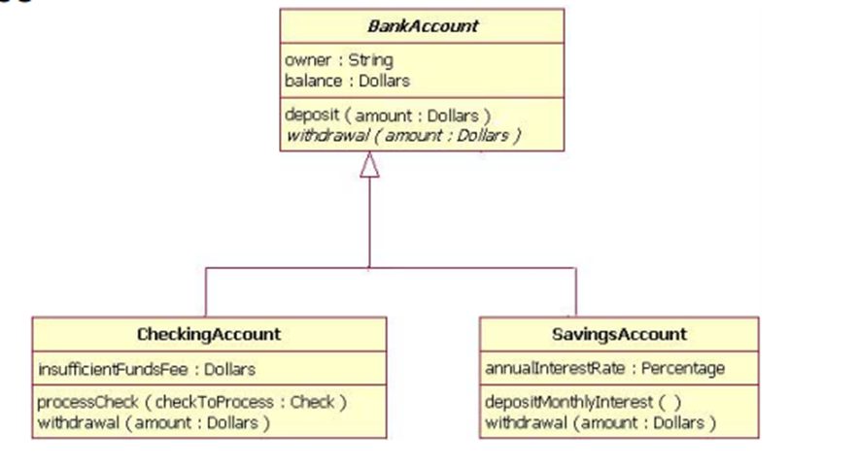

1. Which sentences are true?

a) CheckingAccount implements BankAccount

b) CheckingAccount and SavingAccount are BankAccount

c) CheckingAccount and SavingAccount are associated

d) BankAccount is associated to CheckingAccount

e) SavingAccount can processCheck

f) CheckingAccount has a balance

Answer: A, F, B

2. Write code to implement the class diagram. Write a sequence diagram to create a possible Main() to verify the implementations.

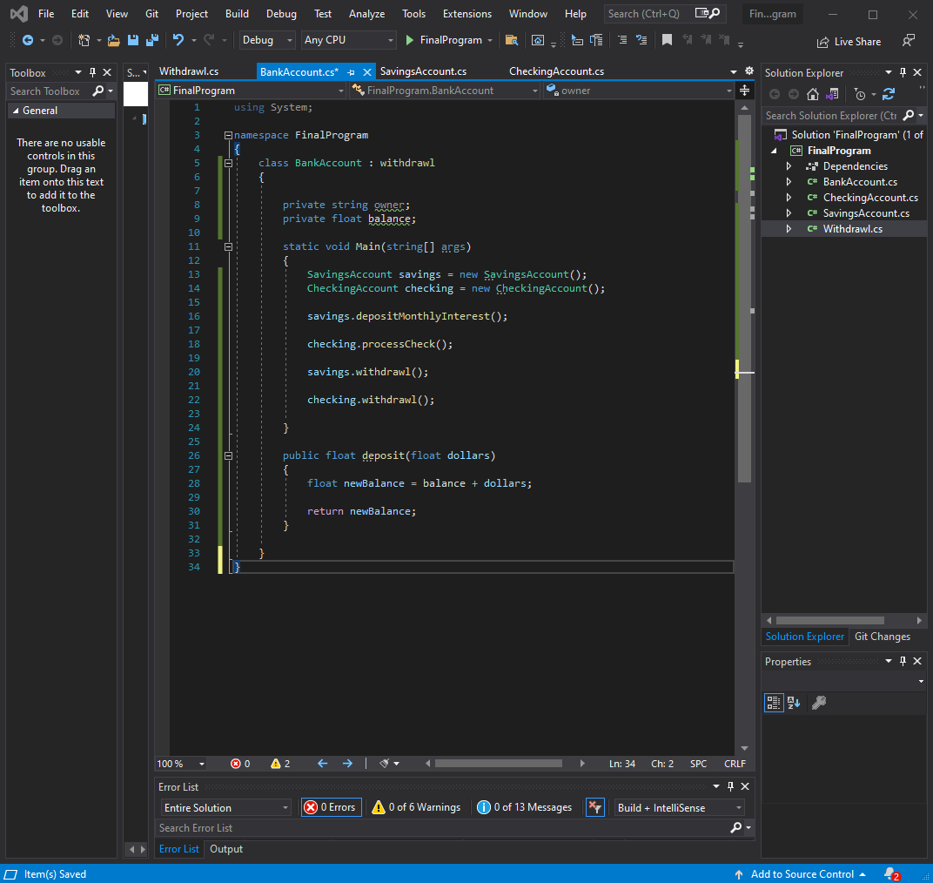

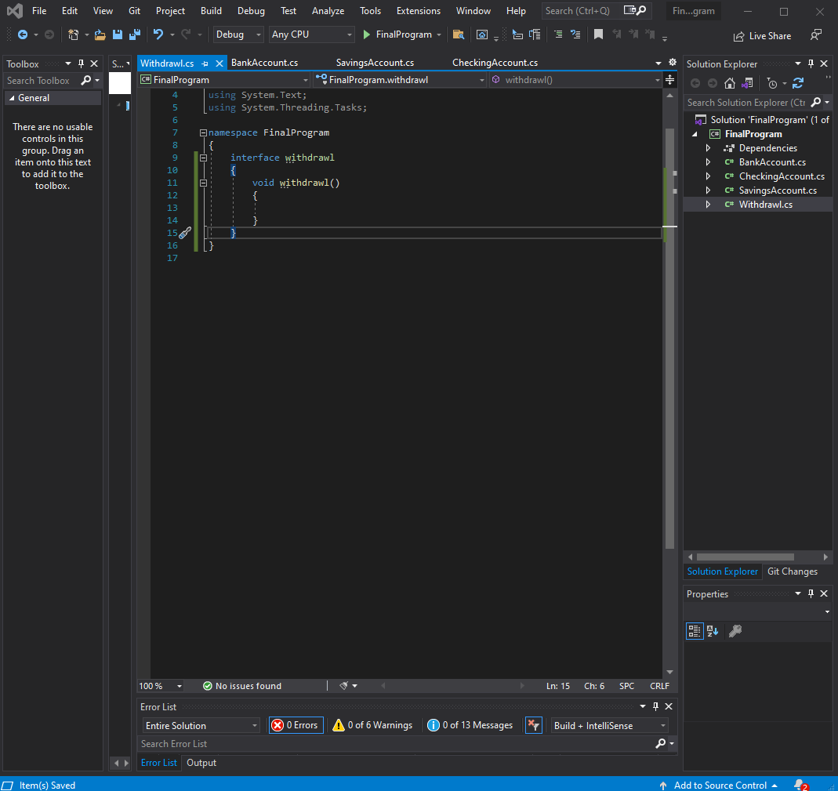

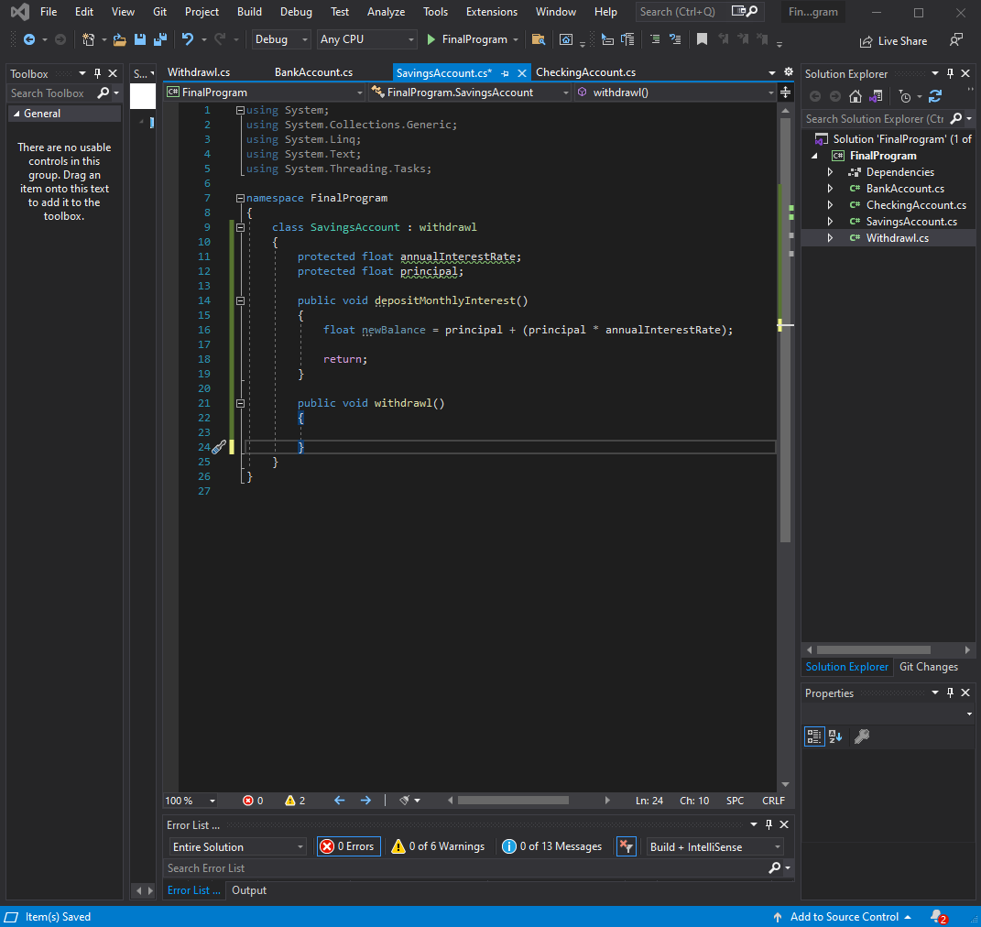

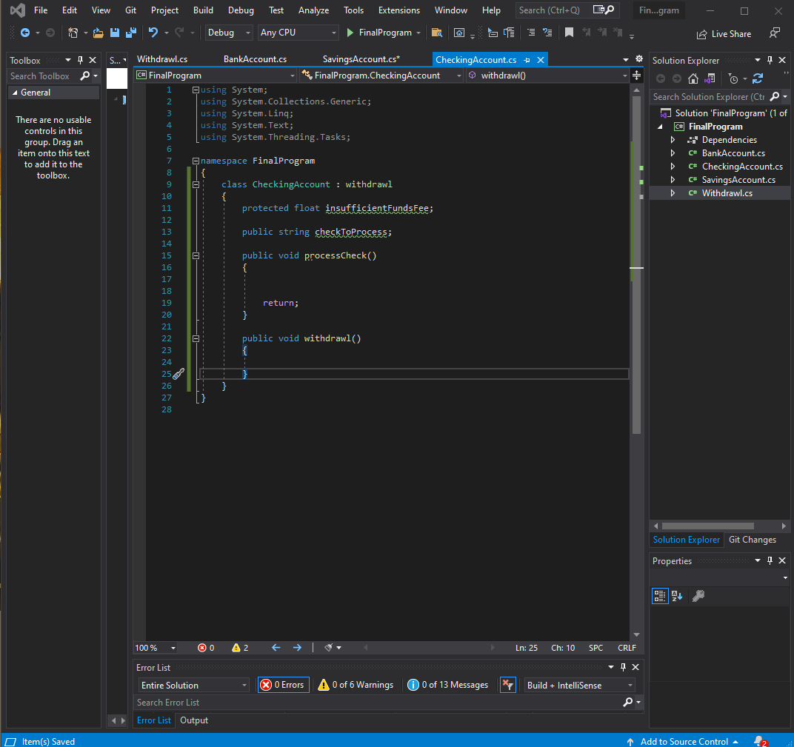

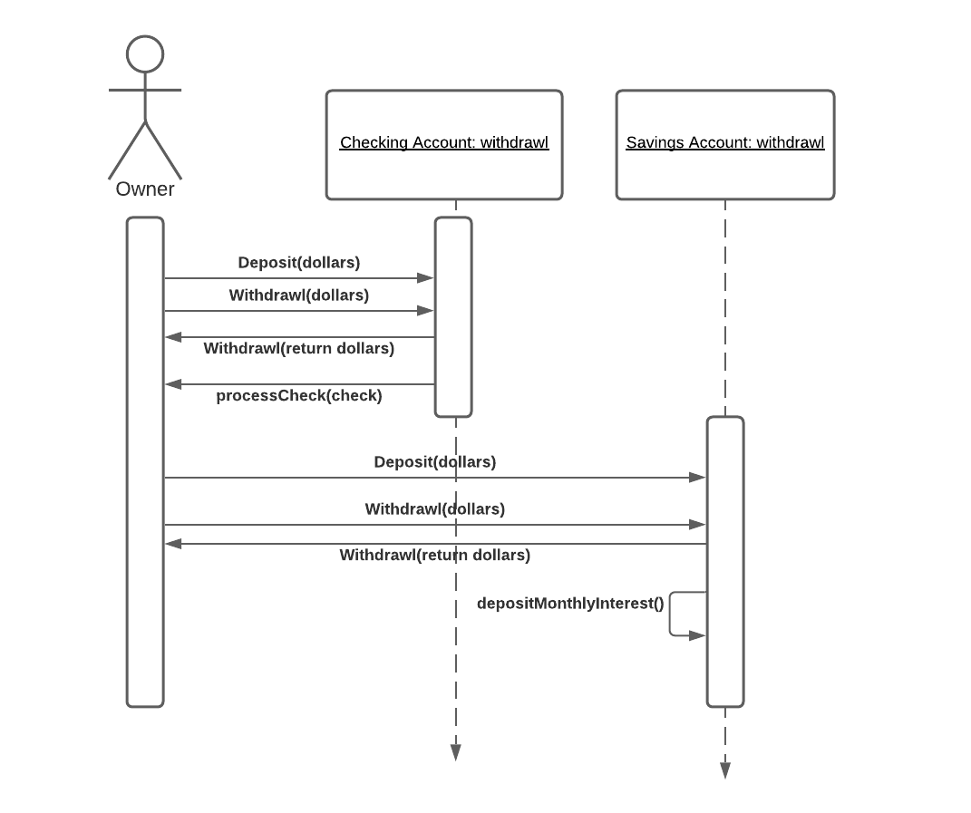

**Problem 4: System Planning & Analysis**

Suppose you are an analyst working for a small company to develop an accounting system. What type of methodology would you use? Why?

I would choose the Scrum AGILE methodology for containerizing critical features into manageable sprints with tangible results that can be reviewed in bi-weekly or other interval meetings. This design methodology will allow for at least a prototype or base of the system to be developed and allow for changes based on current deliverable assessment. This sprint-oriented methodology will also aid in creating a sense of urgency for the development of the accounting system.

**Problem 5: Architecture**

You are relatively new member of a project team that is developing a retail store management system for a chain of sporting goods stores. Company headquarters is in Las Vegas, and the chain has twenty-seven locations throughout Nevada, Utah, and Arizona. Several cities have multiple stores.

* The new system will be a networked client–server architecture.
* Stores will be linked to one of three regional servers, and the regional servers will be linked to corporate headquarters in Las Vegas.
* The regional servers also link to one another.
* Each retail store will be outfitted with similar configurations of two PC-based point-of-sale terminals networked to a local file server.

You have been given the task of developing a network model that will document the geographic structure of this system.

1. Using a deployment diagram, draw a network model for this organization.
2. Prepare a set of instructions to follow in developing a hardware and software specification.

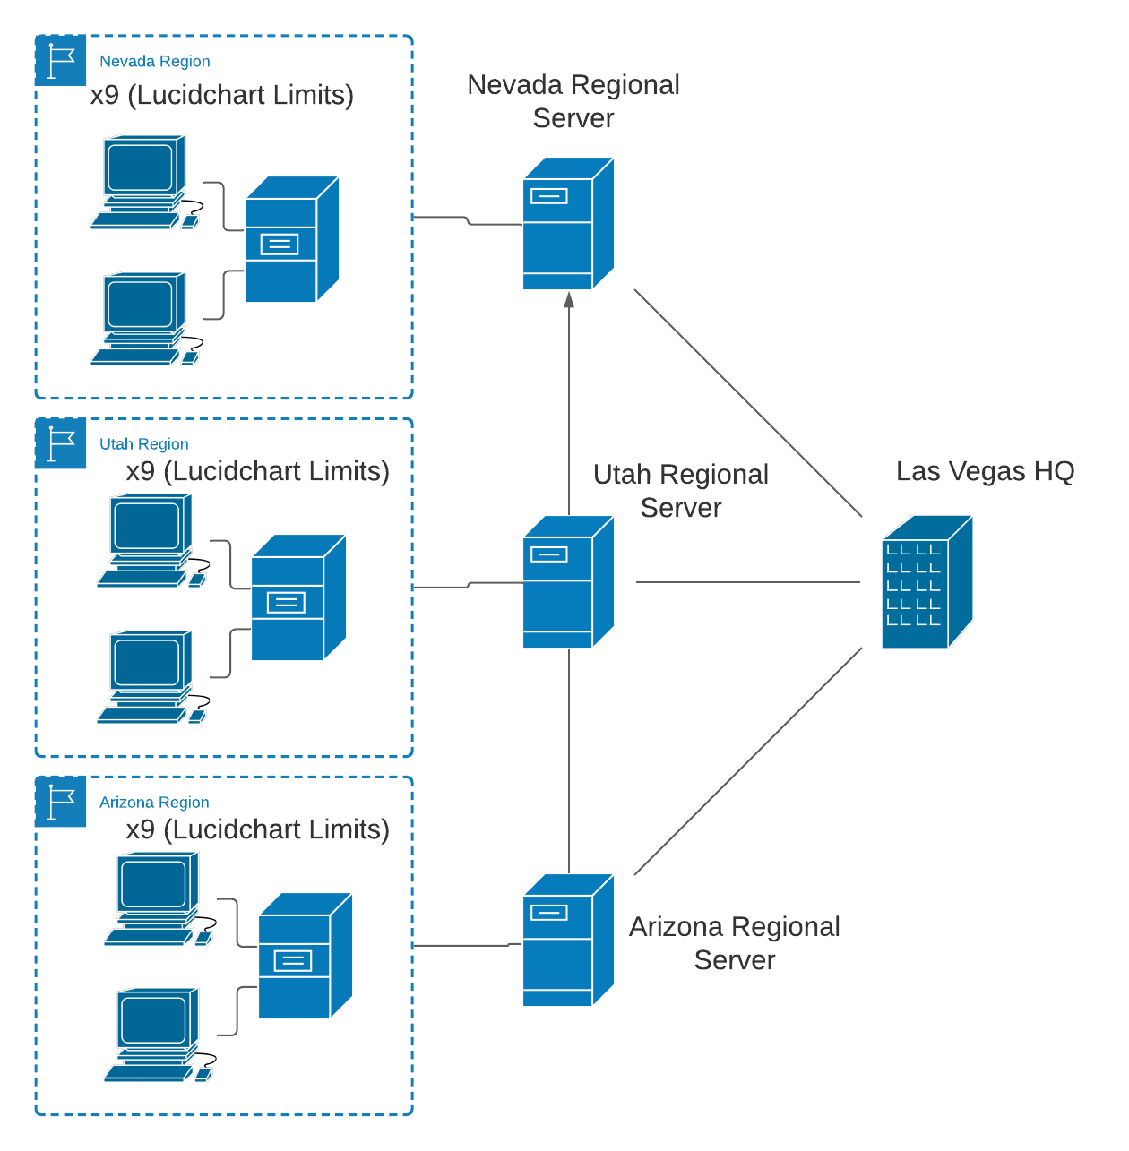

Functions and Features: Business grade desktop PCs with simple monitors up to 20” in diagonal measurement would be sufficient. Dimensions of PC case and monitor may vary per location requirements.

Performance: CPU should process at no less than 2.0GHz/s and RAM capacity should be no less than 4GB. Can use Hard Disk Drive (HDD) with at least 6000RPM or a Solid-State Drive (SSD) of equivalent capacity. Increasing these values and upgrading the hardware will increase processing speed and read/write speed respectively.

Legacy Databases and Systems: Migration to SQL solution would be recommended for access to more efficient data management interfaces/tools if not already established. Otherwise, reviewing data storage and retrieval procedures and requirements would be advised to seek potential improvements. If no backups are created, create local backups for each location, backups for each location on regional servers and backups of all locations and servers at HQ.

Hardware and OS Strategy: For this solution, we could potentially keep a great deal of our current hardware supplies. A cost assessment would need to be drafted to weigh upgrading by reconfiguring existing devices over procuring newer equipment. In any case, vendor continuity should be kept between all systems and devices to allow for easier internal troubleshooting in the future.

Cost of Ownership: Most costs should remain consistent through this new structuring. The highest variability will be determined when a decision is concluded on the Hardware and OS strategy in addition to any new procured software solutions. Additional costs may come from perpetual license fees which are scalable to our needs going forward.

Political Preferences: The work environments should not change dramatically as a result of this implementation. Additional measures should be taken to reinforce technology safety practices and procedures for staff to mitigate social engineering or user error prone attacks.

Vendor Performance: In the business world, Intel is typically reliable and oriented towards improved business server technologies. Perhaps they would be the ideal candidate to procure parts, systems and other packages for deploying this solution.