1. Install MongoDB database server
2. Create a directory/folder to store MongoDB datafiles
3. Set necessary path environment variable
4. Startup MongoDB database
5. Connect to MongoDB database through the MongoDB shell command line interface

6. View list of available databases
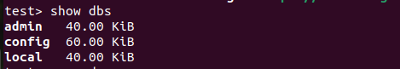

7. Create a new database named CDAC and connect to it
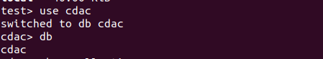

8. View list of available collections in CDAC database
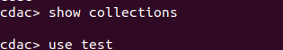

9. Create a new collection by the name of LIBRARY

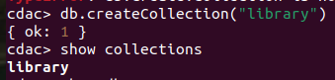

10. Insert the following document in the LIBRARY collection:-

title:'MongoDB programming', author:'Sameer', likes:100
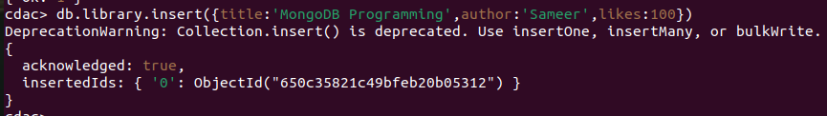
11. View the recently inserted document and note the _id field

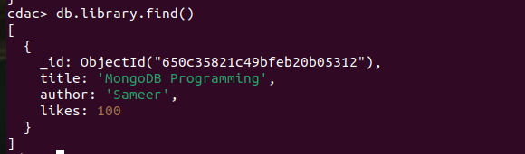

12. Insert another document in the LIBRARY collection as follows:-

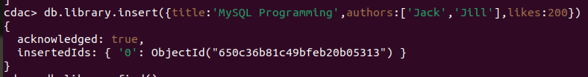
title:'MySQL programming', authors:['Jack','Jill'], likes:200

13. View the inserted documents

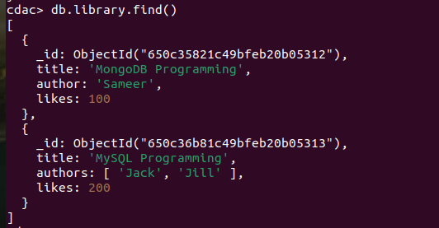

14. View only the first inserted document

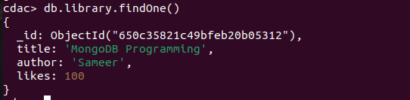

15. View the documents using the pretty() method

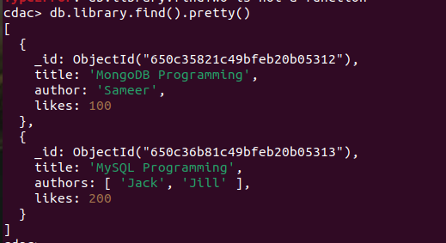

16. Update the document where author name = Sameer and change it to Sameer Dehadrai

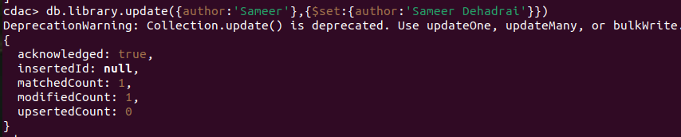

17. Delete all documents that have 100 likes

18. Drop the LIBRARY collection

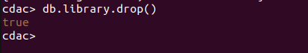

19. Drop the CDAC database

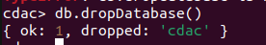

20. Exit from MongoDB shell

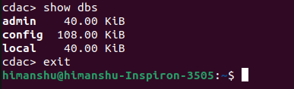

21. Stop MongoDB server

