ASSIGNMENT – 6

Q. Using Special operators in conditions.

1) Write two different queries that would produce all orders taken on october 3rd or 4th,1990.

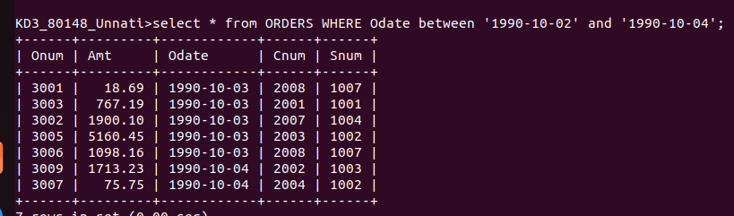

k2) Write a query that selects all of the customers serviced by peel or motika.


3) Write a query that will produce all the customers whose names begins with letter from ‘A’ to ‘G’
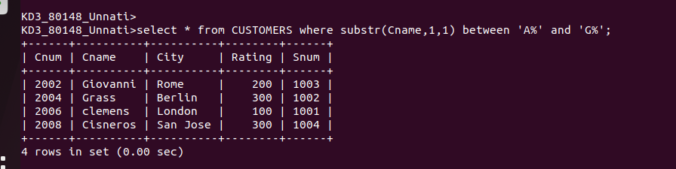

4) write a query that selects all customers whose names begin with letter ‘C’
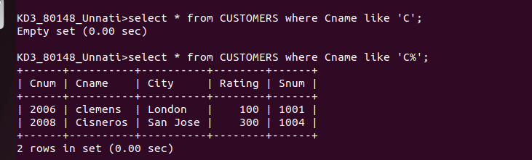

5) write a query that selects all orders except those with zeroes or NULLs in the amt field.

