ASSIGNMENT – 7

1) Write a query that all orders for october 3.

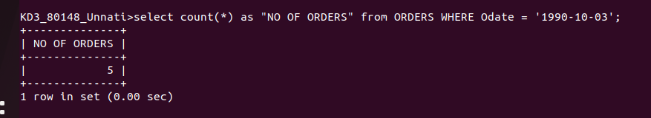

2) Write a query that counts the number of different non null citiy values in the customer table.



3) Write a query that selects each customer smallest order.
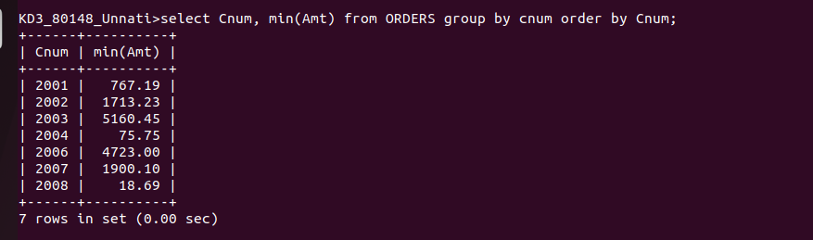

4) Write a query that selects first customer in alphabetical order whose name begins with G.



5) write a query that selects a highest rating in each city.


6) write a query that counts the number of salespeople registering orders for each day.

