ASSIGNMENT NO. 12

Using the operators IN , ANY ,ALL.

Q.1. Write a query that slects all customers whose rating are equal to or greater than ANY of SERRES
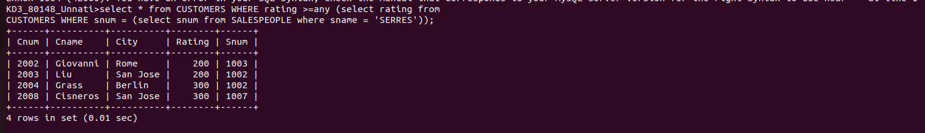

Q.2. Write a querty using ANY or ALL that will find all salespeople who hane no customer located in their city.

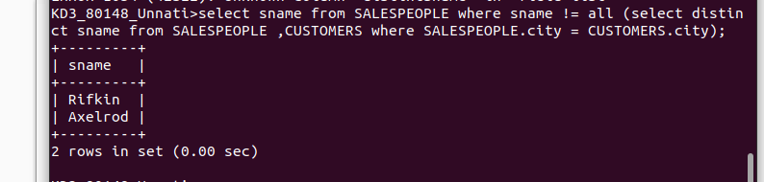

Q.4. Write the above query using MIN or MAX.

