ASSIGNMENT – 8

1) Assume each salesperson has a 12% comm .......



2) Write a query on the customers table that will find the highest ratingin each city in given format...

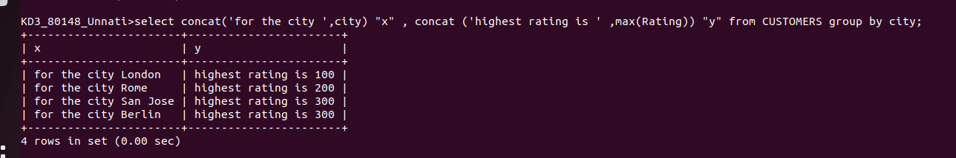

3) Write a query that list customers in descending order of rating...



4) Write a query that totals the orders for each day and places the results in descending order.



