ASSIGNMENT-11

Q.1 Write a query that uses a subquery to obtain all orders from customer named cisneros.Assume you do not know his customer number(cnum).

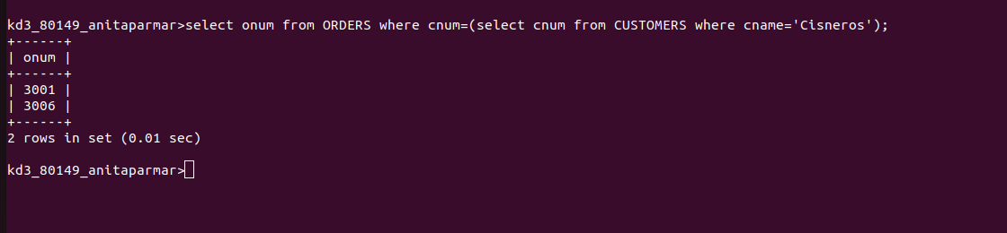

Q.2 Write a query that produses the names and rating of all customers who have above-average orders.

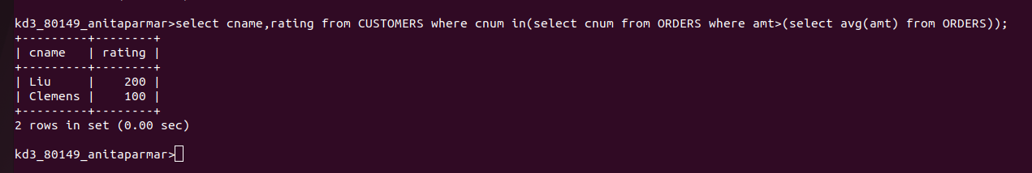

Q.3 Write a query that selects the total amount in orders for each salesperson for whom this total is greater than the amount of the largest order in the table.

