ASSIGNMENT-13

1) Create a union of two queries that shows the names ,cities,and ratings of all customers . Those with rating of 200 or greater will also have the words “High Rating”, while the others will have the words “ Low Rating”.

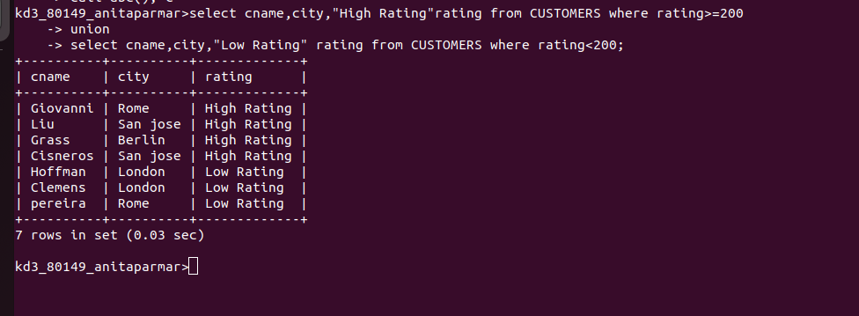

2) Write a command that produces the name and number of each salesperson and each customer with more than one current order. Put the results in alphabetical order.

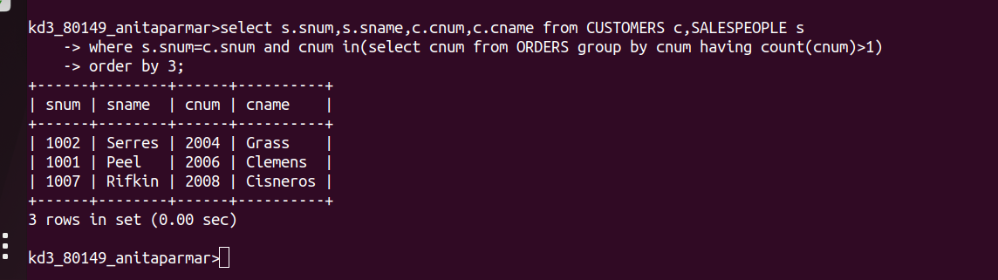

3) Form a union of three queries. Have the first select the snums of all salespeople in San Jose; the second, the cnums of all customers in San Jose; and the third the onums of all orders on October 3. Retain duplicates between the last two queries but eliminate any redundancies between either of them and the first.

