Assignment -9

1) Write a query that lists each order number followed by the name of the customer who made the order ?

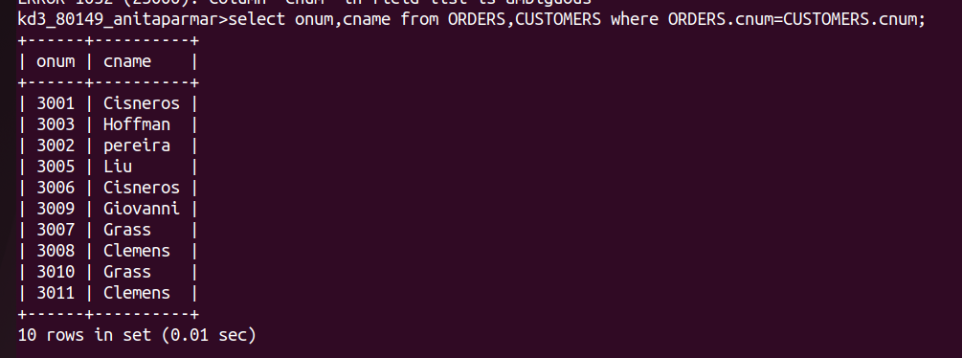

2) Write a query that gives the names of both salesperson and the customer for each order along with the order number.

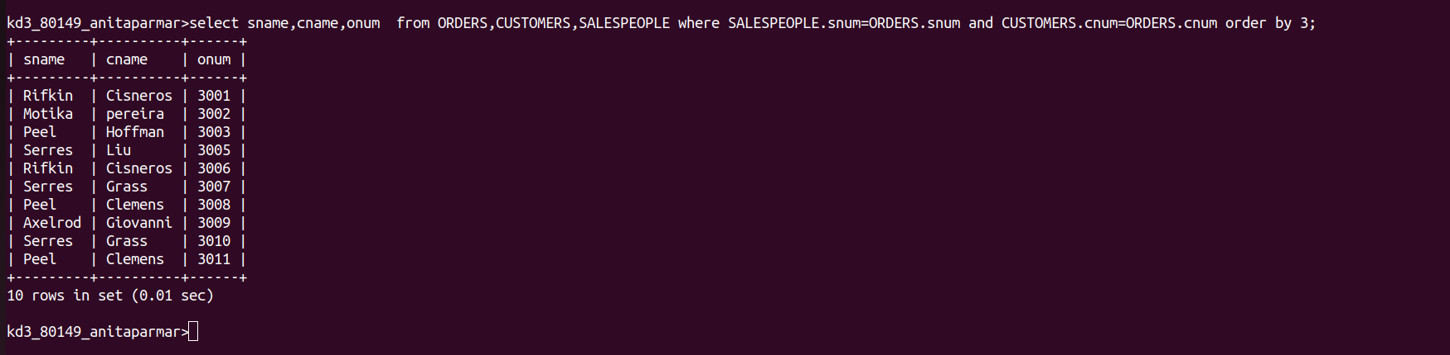

3) write a query that produces all customers serviced by salespeople with a commission above 12%.output the customer’s name,the salesperson’s name,and the salesperson’s rate of commission.
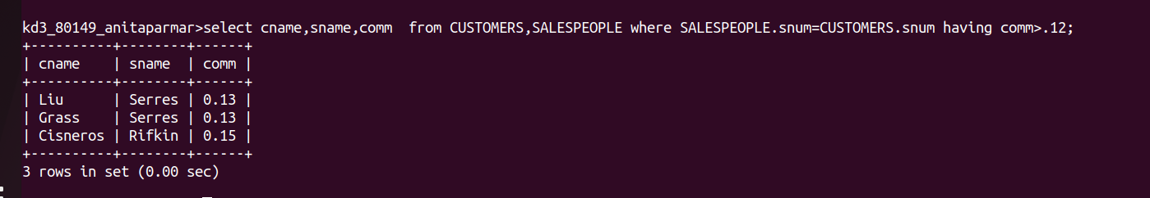

4) write a query that calculates the amount of the Salesperson’s commission on each order by a customer with arating above 100.

