ASSIGNMENT -8

1)Assume each salesperson has 12% commission write a query on the orders table that will produce the order number,the salesperson number , and the amount of the salesperson’s commission for that order.



2) write a query on the customers table that will find the highest rating in each city.

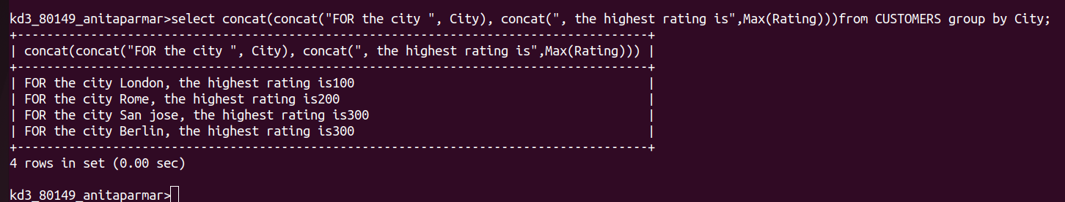
3)write a query that lists customers in descending order of rating.output the rating field first,followed by the customers name and number.



4)write a query that totals the orders for each day and the places the results in descending order.

