Assignment -7

1)write a query that counts all orders for october 3?


2) write a query that counts the number od different non-null city values in the customers table.



3)write a query that selects each customers smallest order.

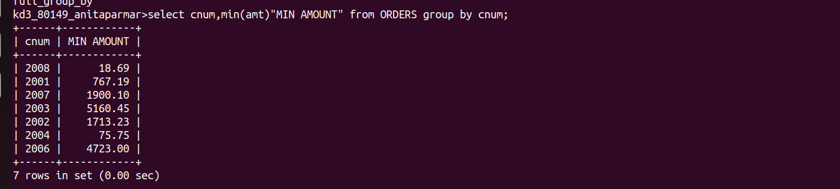
4)write a query that selects the first customer,in alphabetical order,whose name begins with G.


5) write a query that selects the highest rating in each city.


6)write a query that counts the number of salespeople registering orders fro each day.



