ASSIGNMENT-14

1) Write a command that puts the following values , in their given orders , into the salespeople table: city- san jose, name- Blanco, comm-null, cnum-1100.

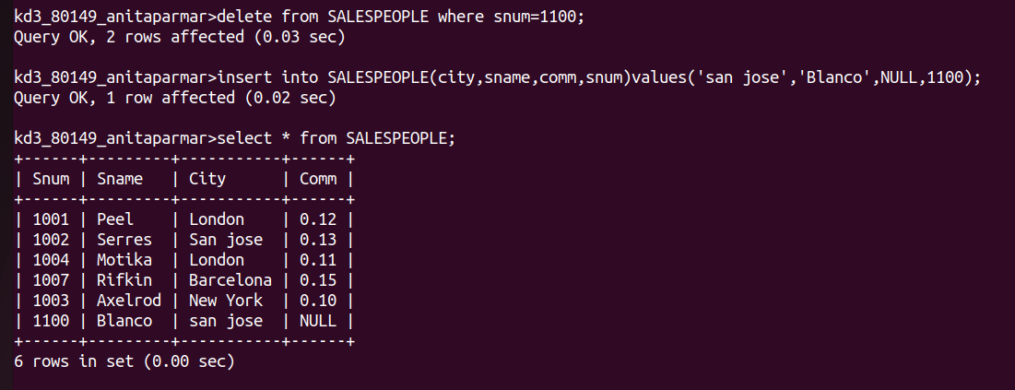

2) Write a command that removes all orders from customer Clemens from the orders table.

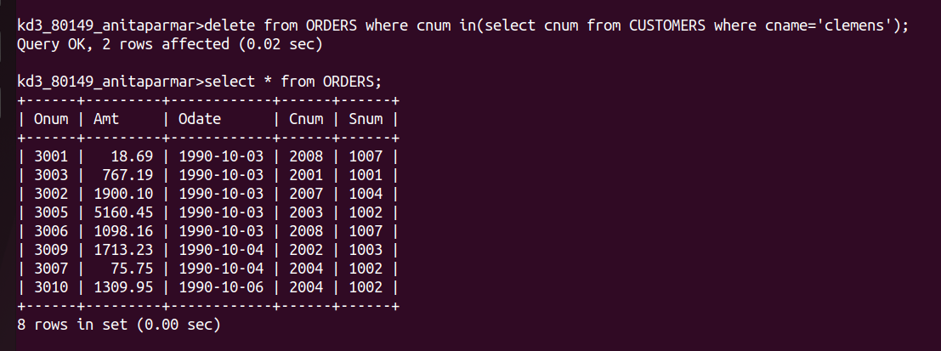

3) Write a command that increases the rating of all customers in rome by 100.

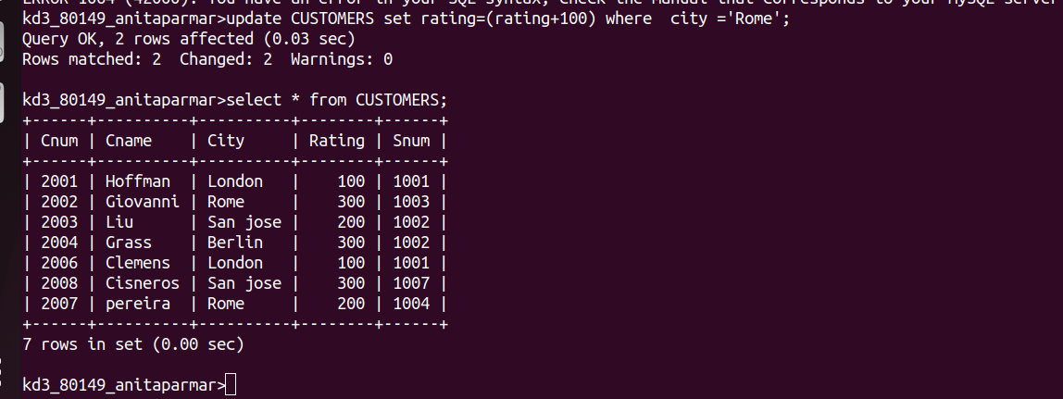

4) Salesperson Serres has left the company .Assign her customers to Motika.

