ASSIGNMENT -12

1) Write a query that selects all customers whose ratings are equal to or greater than any of Serres.

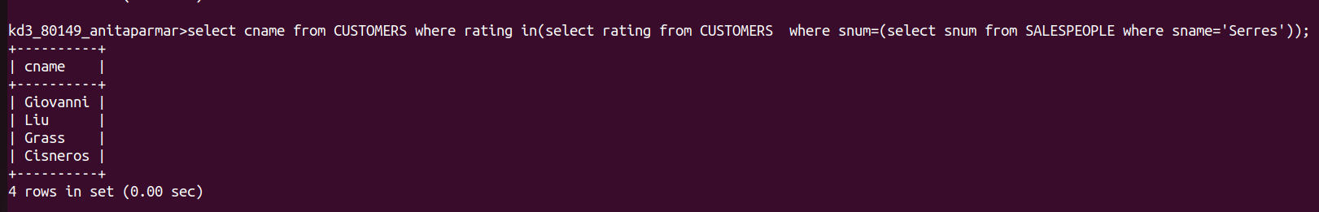

2)Write a query using ANY or All that will find all Salespeople who have no Customers located in their city.

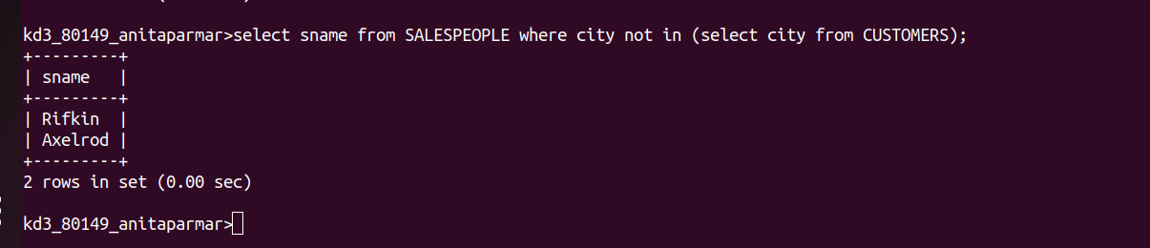

3) Write a query that selects all orders for amounts greater than any for the Customers in London.

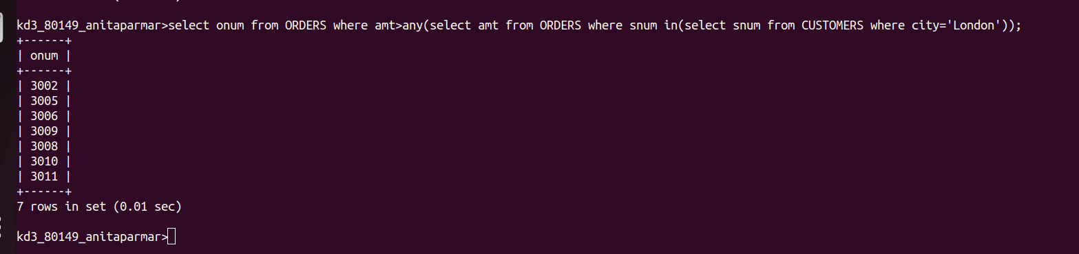

4) write the above query using MIN or MAX.

