Assignment 8

Formating Query Output.

1. Assume each salesperson has 12 % commission. Write a query on the orders table that will produce the order number, the salesperson number and the amount of salesperson’s commission for that order.

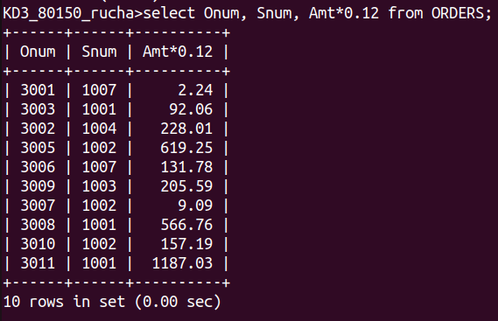

2. Write a query on the Customers table that will find the highest rating in each city, Put the output in this form : For the city (city), the highest rating is : (rating).

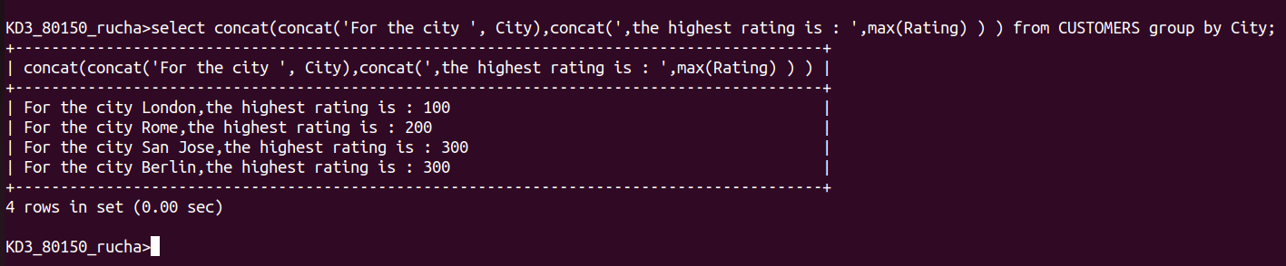

3. Write a query that lists customers in descending order of rating. Output the rating,field first, followed by the customer’s name and number.

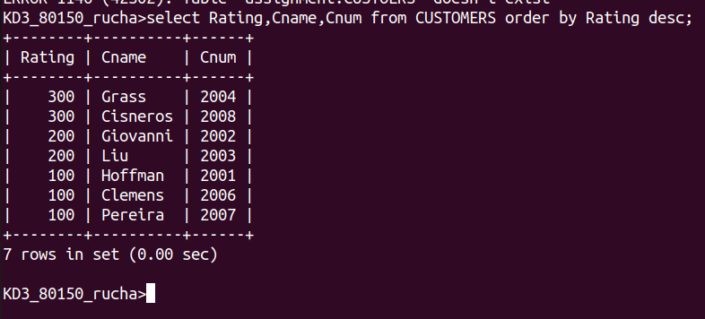

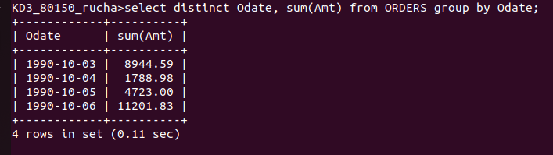
4. Write a query that totals the orders for each day and places the results in descending order.

