Assignment 1
Creating sample tables and inserting values

1. Create the following tables with the given structures and insert sample data as specified:-
Ans.
1.Customer table
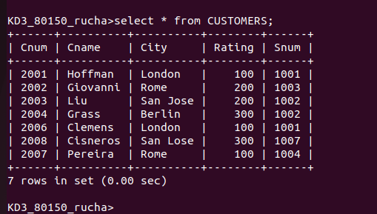

2. Order Table
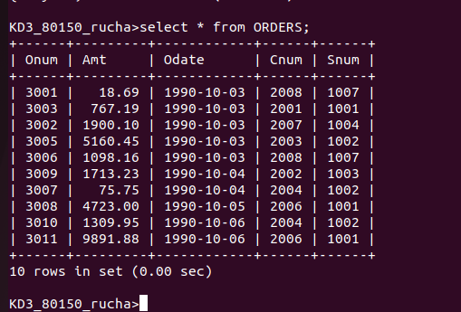

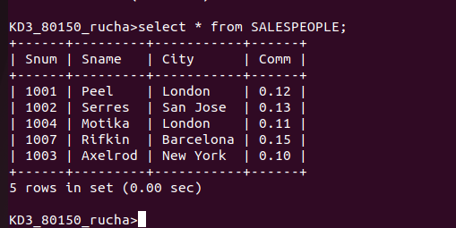
3. Salespeople Table

