Assignment 4

1. Write a select command that produces the order number, amount and date for all rows in the Order table.

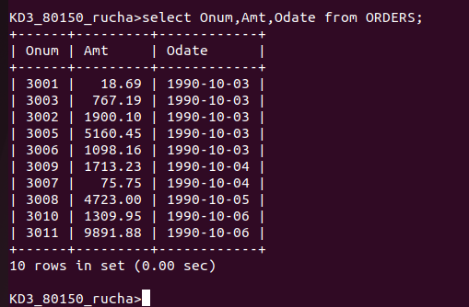

2. Write a query that produces all rows from the Customers table for which the salesperson’s number is 1001.

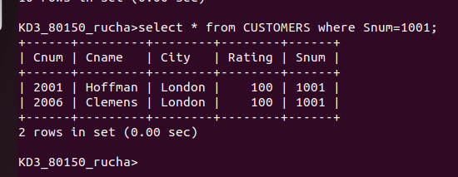

3. Write a query that displays the salespeople table with the column in the following order : city, sname, snum, comm.

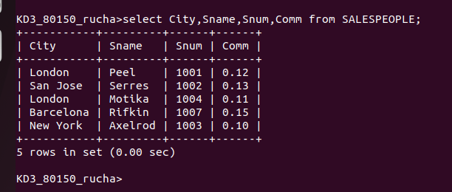

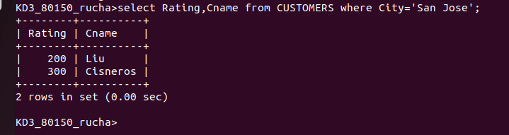
4. Write a select command that produces the rating followed by the name of each customer in San Jose.

