Assignment 7

Summarizing Data with Aggregate Functions.

1. Write a query that counts all orders for October 3.

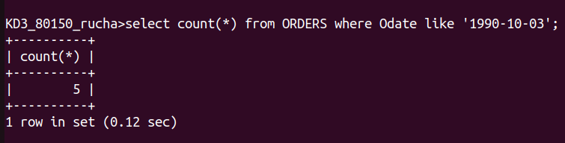

2. Write a query that counts the number of different non-NULL city values in the Customer table.



3. Write a query that selects each customer’s smallest order.

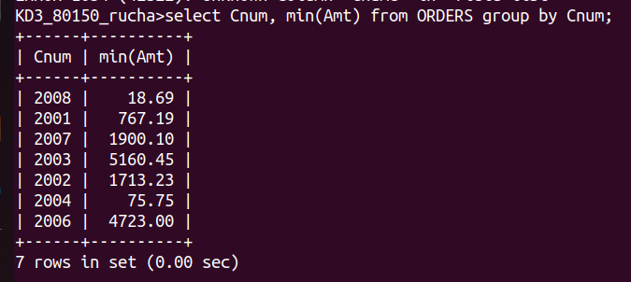

4. Write a query that selects the first customer, in alphabetical order, whose name bagins with G.


5. Write a query that selects the highest rating in the city.

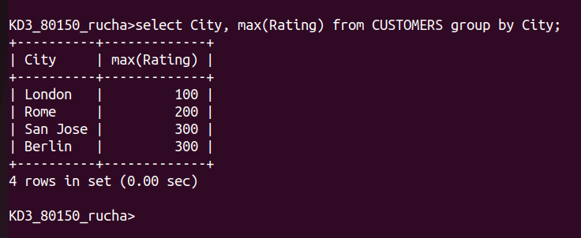
6. Write a query that counts the number of salespeople registering order for each day.(If a salesperson has more than one order on a given day he or she should be counted only once.).

