Assignment 6

Using Special Operators in Condition.

1. Write two different queries that would produce all orders taken on October 3rd or 4th,1990.

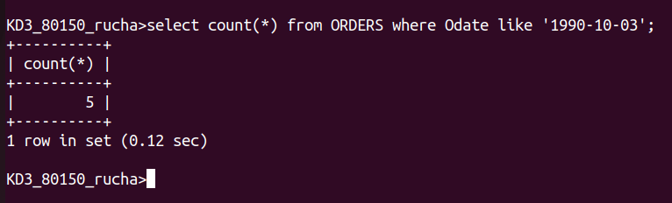

2. Write a query that selects all of the customers serviced by peel or motika. (Hint : the snum field relates the two tables to one another).

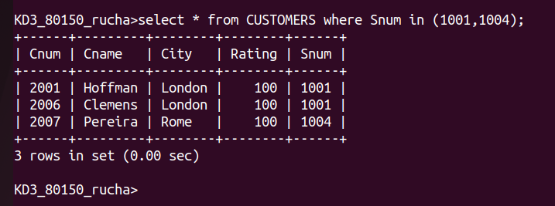

3. Write a query .that will produce all the customers whose names begin with a letter from ‘A’ to ‘G’.
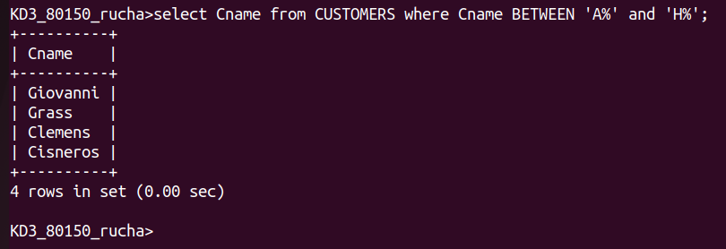

4. Write a query that selects all customers whose names begin with the latter ‘C’.

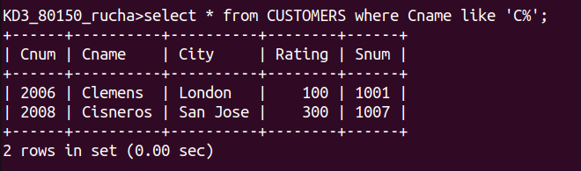

5. Write a query that selects all orders except those with zeros or Nulls in the amt field.

