Assignment 5

Relational and Logical Operators

1. Write a query that will give you all orders for more than Rs. 1000.

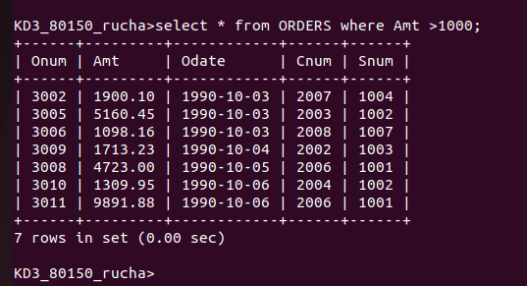

2. Write a query that will give you the names and cities of all salespeople in London with a commision above 0.10.

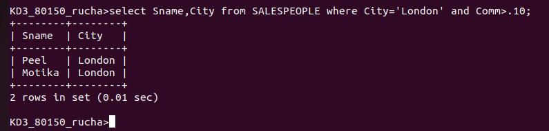
3. Write a query on customer s table whose output will exclude all customers with a rating <=100, unlessthey are located in Rome.
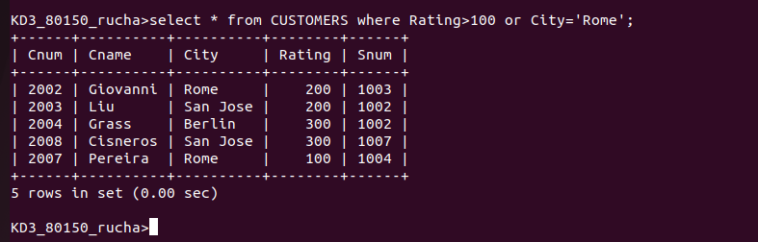

4. What will be the output of the following query?

Select * from orders
where (amt <1000 OR NOT (odate = ‘1990-10-03’ and cnum >2003));

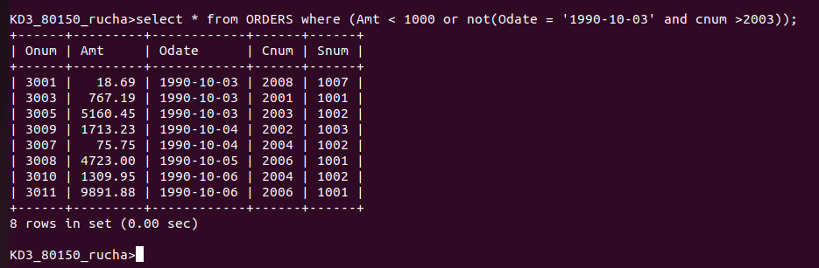
5. What will be the output of the following query?

Select * from orders
where not ((odate = ‘1990-10-03’ or snum >1006)and amt >= 1500);

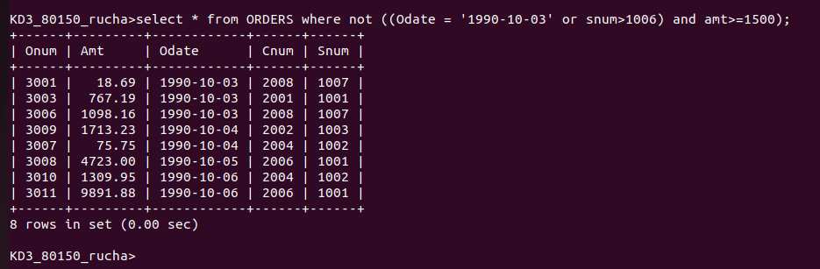

6. What is the simpler way to write this query?

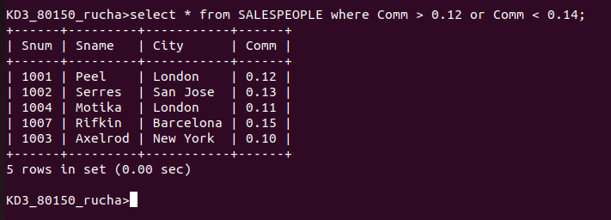
Select snum, sname, city, comm from Salespeople where comm > .12 or comm <.14;

