Assignment 9

Querying Multiple Tables at Once.

1. Write a query that lists each other number followed by the name of the customer who made the order.

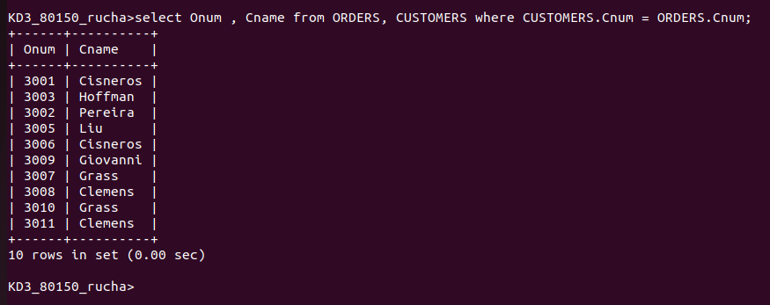

2. Write a query that gives the names of both the salesperson and the customer for each order along with the order mu,ber.

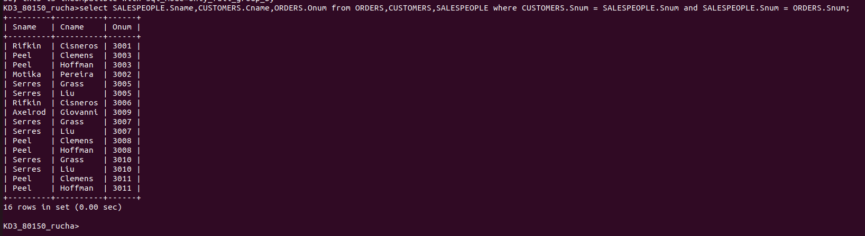

3. Write a query that produces all customers serviviced by salespeople with a commission above 12%. Output the customer’s name , the salesperson’s name and the salesperson’s rate of commission.

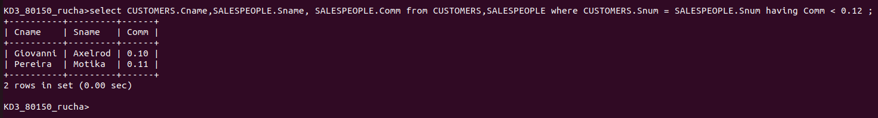

Write a query that calculates the amount of the salesperson’s commission on each order by a customer with a rating above 100.

