ASSIGNMENT-14

Q1 write a command that puts the following values,
in their given orders,into the salespeople table : city -sanjose,name-blanco, comm-null,cnum-1100

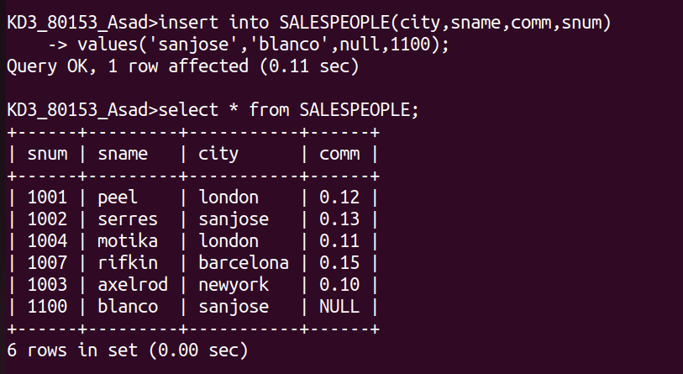

Q2 write a command that removes all orders from customer clemens from orders table

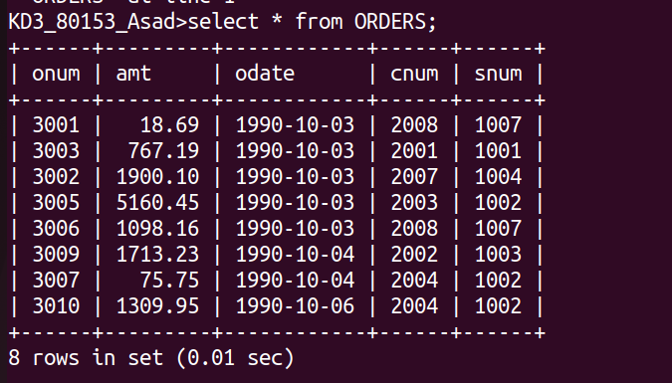
Q3 write a command that increase the rating of all customers in rome by 100

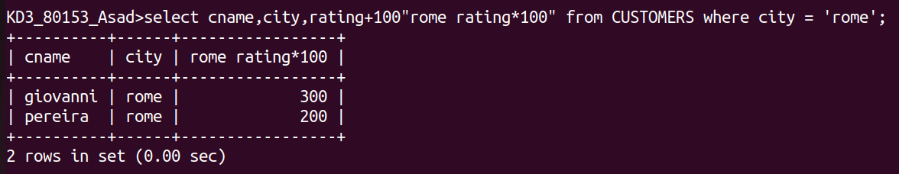

Q4 salesperson serres has left the company .assign her customers to motika

