Assignment – 06

Q1 write two different queries that would produce all orders taken on october 3rd or 4th ,1990

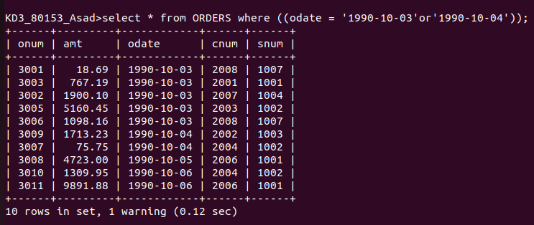

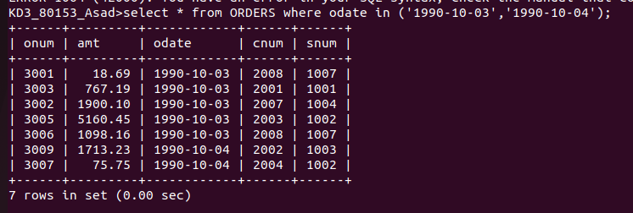

Q2 write a query that selects all of the customers serviced by peel or motika.(hint: the snum field relates the two tables to one another)

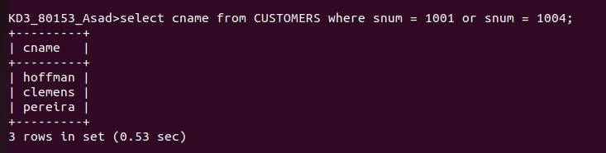
Q3 write a query that will produce all the customers whose names begin with the letter from ‘A’ to ‘G’.

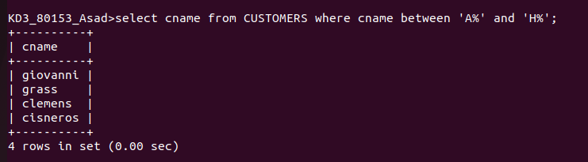

Q4 write a query that will selects all the customers whose names begin with the letter from ‘C’

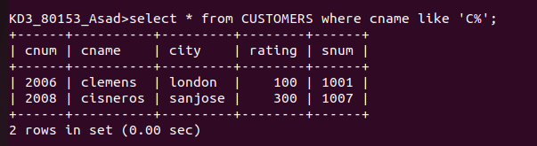

Q5 write a query that selects all the orders except those zeroes or nulls in the amount field.
