ASSIGNMENT -13

Q1create a union of two queries that shows the names,cities, and ratings of all customers those with rating of 200 or greater will also have the words “HIGH RATING” while the others will have the words “LOW RATING”

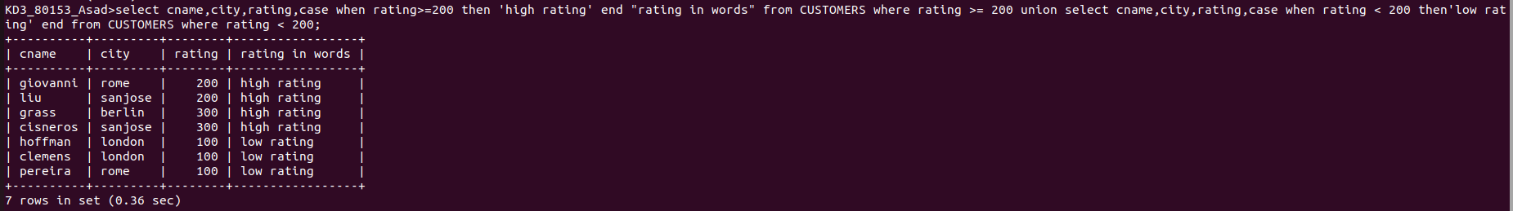
Q2 write a command that produces the name and number of each dalesperson and each customer with more than one current order put the results in alphabetical order
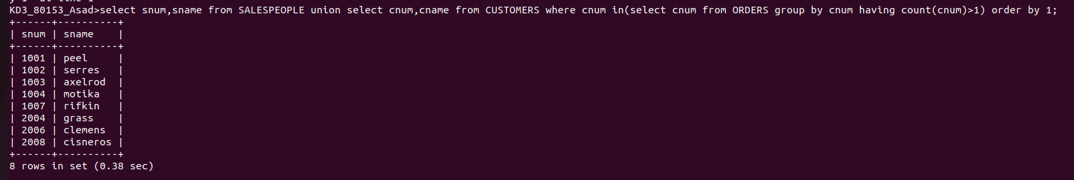
Q3 form a union of three queries have the first select the snum of all salespeople in sanjose; the second, the cnums of all customers in sanjose and the third the onums of all orders on october 3. retain duplicates between the last two queries but eliminate ant redundencies between either of them and the first

