ASSIGNMENT – 05

Q1 write a query that will give you all orders for more than rs 1000.

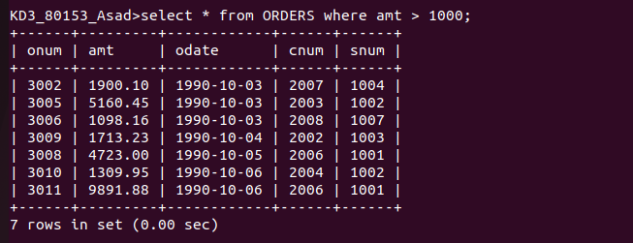
Q2 write a query that will give you the names and cities of all salespeople in london with a commission above.10

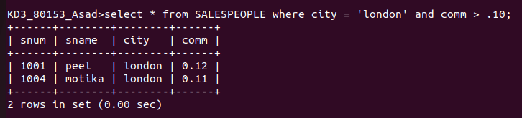
Q3 write a query on the customers table whose output will exclude all customers with rating <=100,unless they are located in rome.

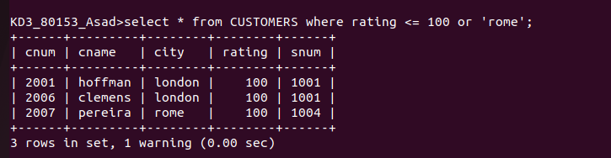
Q4 what will be the output from the following query?
Select * from orders where (amt<10 OR NOT (odate = ‘1990-10-03’ AND cnum > 2003));

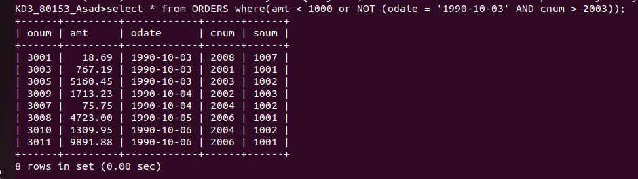
Q5 what will be the output of the following query?
Select * from orders where NOT ((odate = ‘1990-10-03’ OR snum >1006) AND amt >=1500);

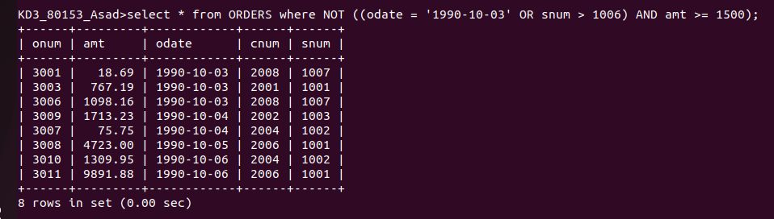
Q6 what is the simpler way to write this query ?
Select snum,sname,city,comm from salespeople where (comm > .12 OR comm< .14);
