ASSIGNMENT -10

Q1 write a query that produces all pairs of salespeople who are living in the same city.exclude combinations of salespeople with themselves as well as duplicate rows with the order reversed

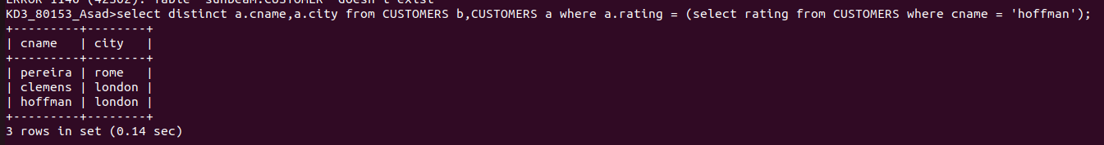

Q2 write a query that produces the names and cities of all customers with the same rating as hoffman

