ASSIGNMENT -11

Q1 write a query that uses a sub query to obtain all orders for the customer named cisneros assume you do not know his customer number (cnum)



Q2 write a query that produces the names and ratings of all customers who have above-average orders
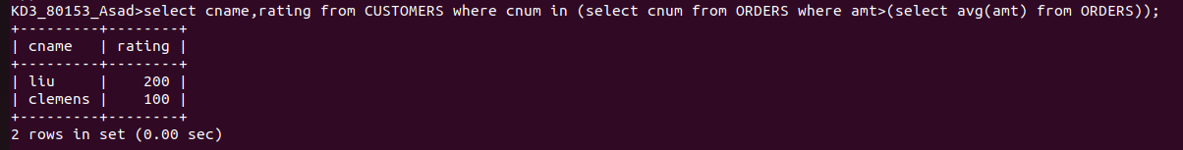
Q3 write a query that selects the total amount in orders for each salesperson for whom this total is greator than the amount of the largest order in the table
