ASSIGNMENT -12

Q1 write a query that selects all customers whose ratings are equal to or greater than any of serres
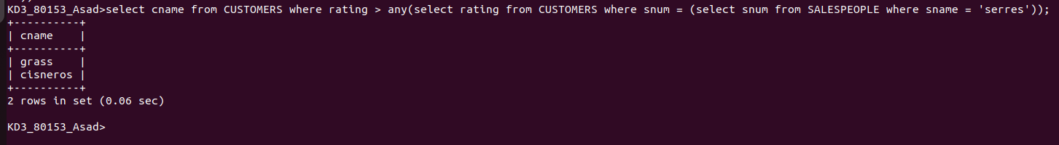
Q2 write a query using any or all that will find all salespeople who have no customers located in their city

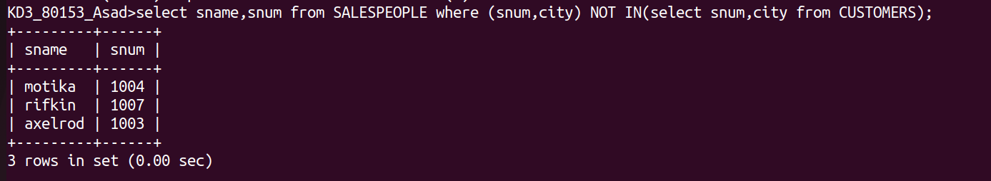
Q3 write a query that selects all orders for amounts greater than any for the customers in london

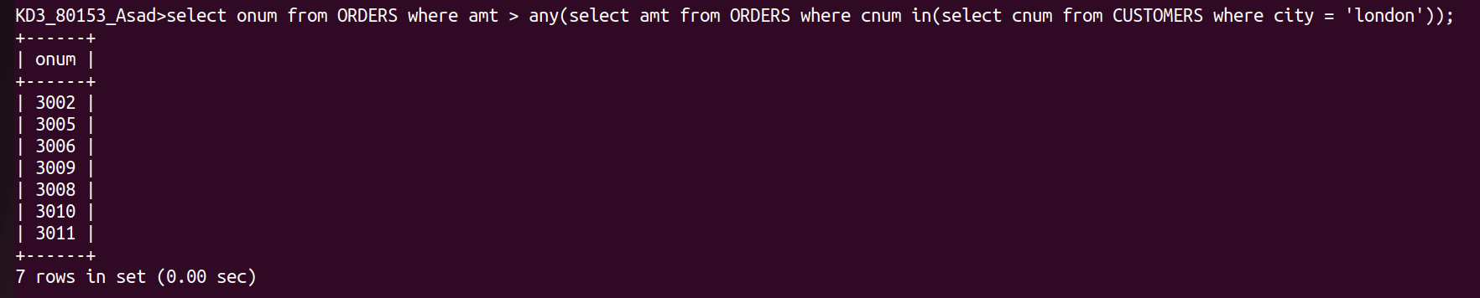

Q4 write the above query using min or max

