ASSIGNMENT -09

Q1 write a query that lists each order number followed by the name of the customer who made the order
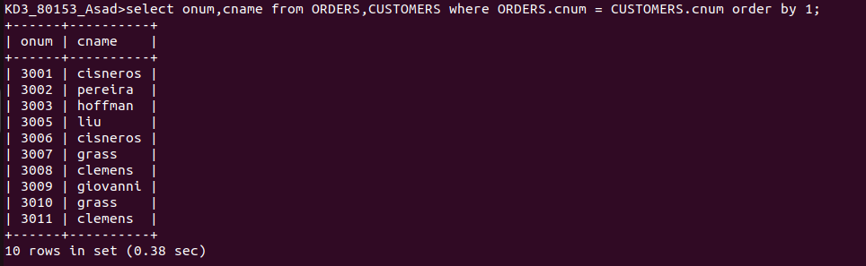
Q2 write a query that gives the names of both the salesperson and the customer for each order along with the order number.
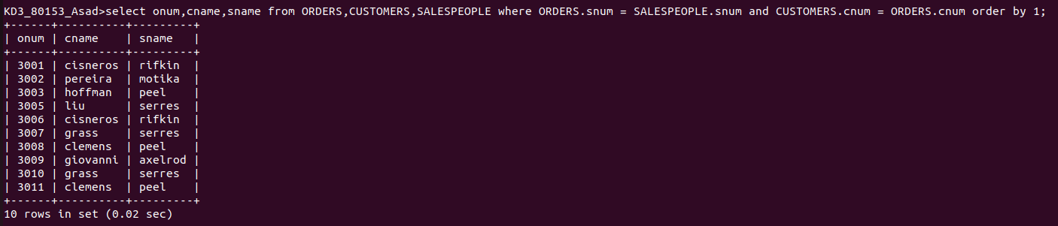
Q3 write a query that produces all customers serviced by salespeople with a commision above 12% output the customers name,the salespersons name,and the salesperson rate of commision

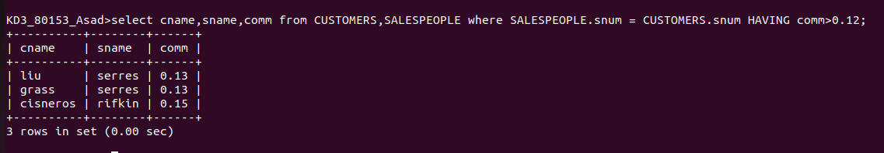

Q4 write a query that calculates the amount of the salesperson’s commision on each order by a customer with a rating above 100.

