ASSIGNMENT -15

Q1 Assume there is a table called multicust,with allm of the same column definitions as salespeople write a command that inserts all salespeople with more than one customers into this table
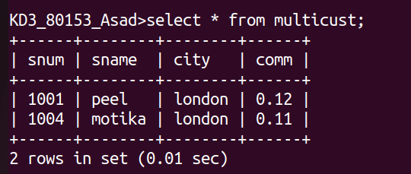

Q2 write a command that deletes all customers with no current orders

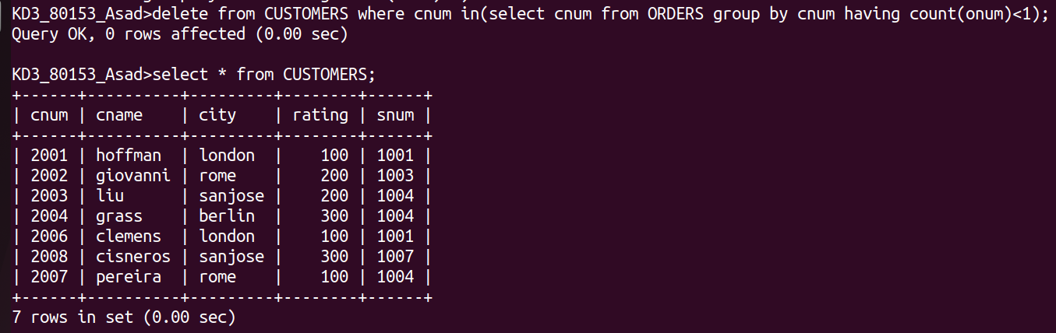
Q3 write a command that increases by twenty percent the comissions of all salespeople with total orders above rs3000

