ASSIGNMENT – 04

Q1 write a select command that produces the order number,amount, and date for all rows in orders table.
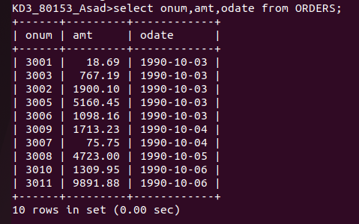

Q2 write a query that produces all rows from the customer table for which the
salespersons number is 1001

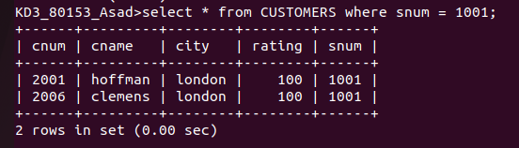

Q3 write a query that displays the salespeople table with the columns in the following order: city,sname,snum,comm.
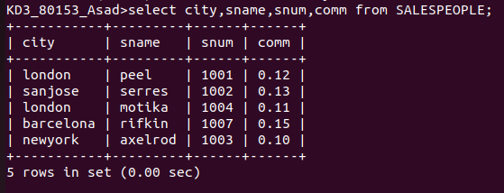
Q4 write a select command that produces the rating followed by the name of each customer in sanjose.

