Assignment 6

Q1. Write two different queries that would produce all orders taken on October 3rd or 4th, 1990.

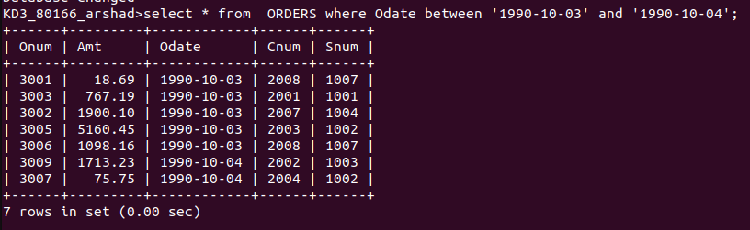

Q2. Write a query that selects all of the customers serviced by Peel or Motika. (Hint: the snum field relates the two tables to one another)

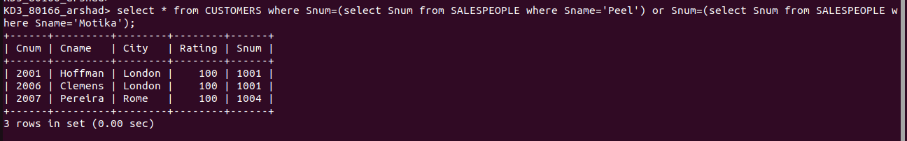

Q3. write a query that will produce all the customers whose names begin with a letter from ‘A’ to ‘G’
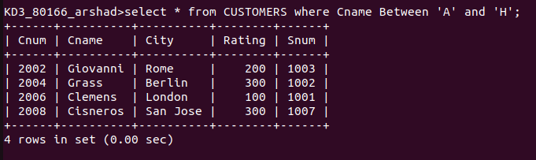

Q4. Write a query that selects all customers whose names begin with letter ‘C’;

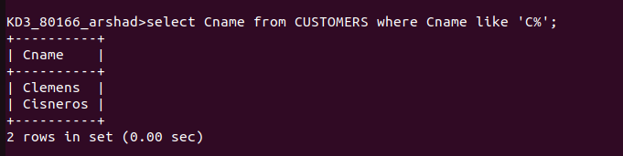

Q5. Write a query that selects all orders except those with zeroes or NULLS in the amt field.

