Assignment 4
Q1. Write a select commant that produces the order number, amount, and date for all the rows in the orders
Q2. Write a query that produces all rows from the Customers table for which the salesperson’s number is 1001
Q3. Write a query that displays the Salespeople table with the columns in the following order:
City, Sname, Sum, comm.
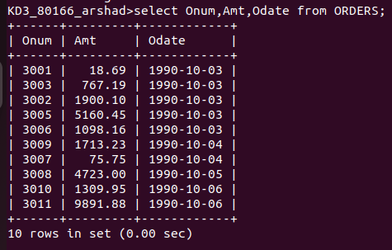

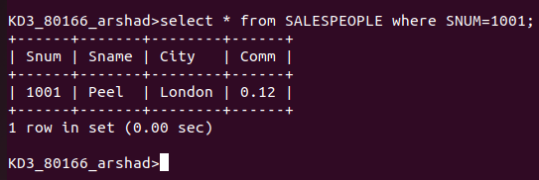

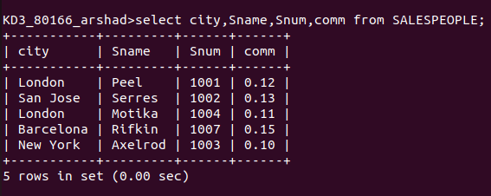

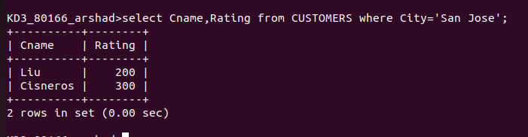
Q4. Write a select command that produces the rating followed by the name of each customer in San Jose

