ASSIGNMENT – 14

1) Write a command that puts the following values in their given order, into the salespeople table, City – San Jose, Name – Blanco, Comm- Null, Cnum – 1100.

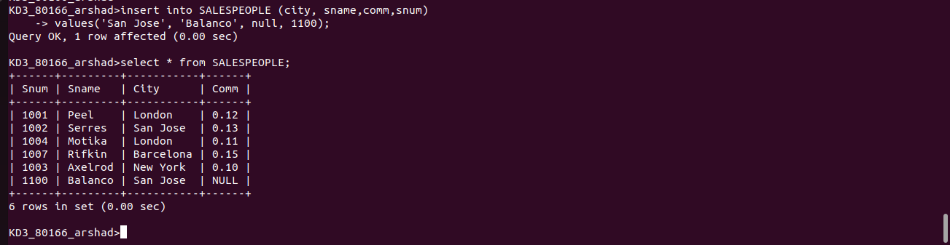
2) Write a command that removes all the orders from customer Clemens from the orders table.

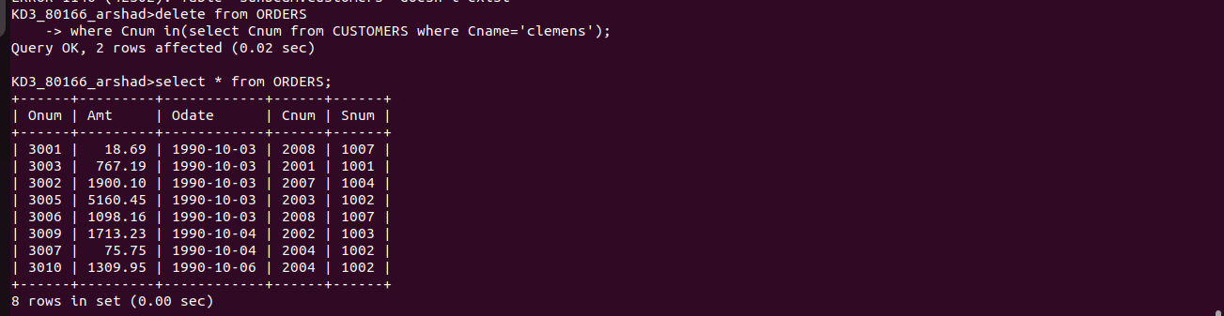

3) Write a command that increases the rating of all customers in Rome by 100.

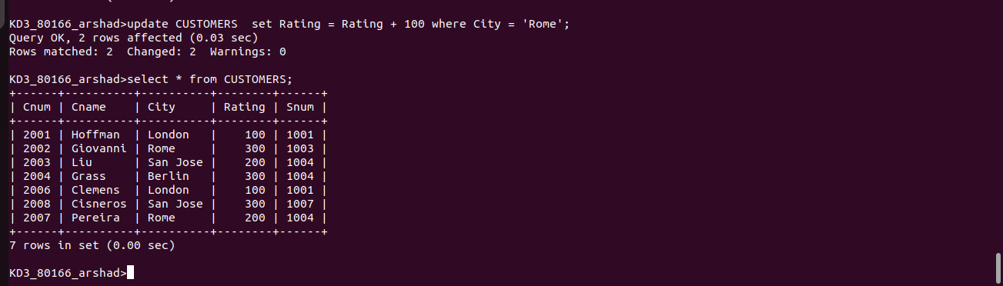

4) Salesperson Serres has left the company. Assign her customers to Motika.
