|  |  |
| --- | --- |
| **A**  **PROJECT REPORT ON** | |
|  | |
|  | |
| Home Services | |
|  | |
|  | |
| SUBMITTED IN  PARTIAL FULFILLMENT OF  **DIPLOMA IN ADVANCED COMPUTING (PG-DAC)** | |
|  | |
|  | |
|  | |
|  | |
|  | |
|  | |
|  | |
| **BY**  **Aishwarya R Dhongdi**  **Kishan Verma**  **Srijan Chandrakar**  **Vinita M Chandel** | |
| **UNDER THE GUIDENCE OF**  **Priyanka Rangole** | |
|  | |
| **AT**  **SUNBEAM INSTITUTE OF INFORMATION TECHNOLOGY,**  **Karad** | |
|  | |
| **SUNBEAM INSTITUTE OF INFORMATION TECHNOLOGY,**  **Karad** | |
|  | |
|  | |
|  | |
|  | |
| **CERTIFICATE** | |
|  | |
| This is to certify that the project | |
|  | |
| Home Services | |
|  | |
| Has been submitted by | |
|  | |
| **Srijan Chandrakar** | |
|  | |
|  | |
| In partial fulfillment of the requirement for the Course of **PG Diploma in Advanced Computing (PG-DAC March 2024)** as prescribed by The **CDAC** ACTS, PUNE. | |
|  | |
|  | |
| Place: Karad | Date: 14-AUG-2024 |
|  | |
|  | |
|  | |
|  | |
|  | |
| **Priyanka Rangole** | **Pratik Ninganur** |
| **Project Guide** | **Course Coordinator** |

**ACKNOWLEDGEMENT**

A project usually falls short of its expectation unless aided and guided by the right persons at the right time. We avail this opportunity to express our deep sense of gratitude towards **Mr. Prashant Lad (Center Coordinator, SIIT, Karad)** and **Mr. Pratik Ninganur (Course Coordinator, SIIT, Karad).**

We are deeply indebted and grateful to them for their guidance, encouragement and deep concern for our project. Without their critical evaluation and suggestions at every stage of the project, this project could never have reached its present form.

Last but not the least we thank the entire faculty and the staff members of Sunbeam Institute of Information Technology, Karad for their support.

Srijan Chandrakar

**DAC March 24 Batch,**

**SIIT Karad**

**INDEX**

|  |  |  |
| --- | --- | --- |
|  | **INTRODUCTION** | 1 |
|  | 1.1 Introduction | 1 |
|  | 1.2 Key Objectives | 1 |
|  | 2.2 Scope | 1-2 |
|  | **REQUIREMENTS** | 3-8 |
|  | * 1. Functional Requirements | 3-7 |
|  | 2.1.1 Customer Interaction. | 3-5 |
|  | 2.1.2 Additional Information. | 5-6 |
|  | 2.1.3 Error Handling | 6 |
|  | 2.1.4 Security | 7 |
|  | 2.2 Non - Functional Requirements | 8 |
|  | 2.2.1 Interface | 8 |
|  | 2.2.2 Hardware Interfaces | 8 |
|  | 2.2.3 Software Interfaces | 8 |
|  | **PROJECT DESIGN** | 9-12 |
|  | 3.1 Data Model | 9-12 |
|  | 3.1.1 Database Design | 9-12 |
|  | 3.1.2 Diagrams | 12 |
| **4.** | **CODING-STANDARDS** | 13-14 |
|  | 4.1. Naming and Capitalization | 13 |
|  | 4.2. Comments | 14 |
| **5.** | **TEST REPORT** | 15 |
| **6.** | **PROJECT RELATED STATISTICS** | 16-17 |
| **7.** | **DIAGRAMS & SCREENSHOTS** | 18-26 |
| **8.** | **BIBLIOGRAPHY** | 27 |

**LIST OF TABLES**

|  |  |  |
| --- | --- | --- |
| **Section** | **Table Title** | **Page** |
| **3.1** | **Categories** | 9 |
| **3.1** | **Services** | 9 |
| **3.1** | **Customers** | 9-10 |
| **3.1** | **Workers** | 10 |
| **3.1** | **Status** | 10 |
| **3.1** | **Ratings** | 11 |
| **3.1** | **Bookings** | 12 |
| **4.1** | **Naming and Capitalization** | 13 |
| **5.** | **Test Report** | 15 |
| **6.** | **Project Management Related Statistics** | 16-17 |

**LIST OF FIGURES**

|  |  |  |
| --- | --- | --- |
| **Section** | **Figure Title** | **Page** |
| **2.1** | **Customer Use Case Diagram** | 3 |
| **7.** | **Entity Relationship Diagram** | 18 |
| **7.** | **Class Diagram** | 19 |
| **7.** | **Worker Use Case Diagram** | 20 |
| **7.** | **Admin Use Case Diagram** | 21 |
| **7.** | **Homepage** | 22 |
| **7.** | **Login Popup** | 22 |
| **7.** | **Administrators Login** | 23 |
| **7.** | **User Registration** | 23 |
| **7.** | **Booking Status Notification** | 24 |
| **7.** | **Booking Details** | 24 |
| **7.** | **Worker Login** | 25 |
| **7.** | **Task Booking Details** | 25 |
| **7.** | **Admin Page** | 26 |

# **INTRODUCTION TO PROJECT**

Household Service is an innovative digital platform tailored to streamline the process of finding and hiring household workers. Designed with both customers and workers in mind, the platform offers a reliable, efficient, and user-friendly experience that significantly reduces the complexities traditionally associated with hiring domestic help.

By bridging the gap between customers and qualified household professionals, Household Service not only simplifies the hiring process but also creates a dynamic marketplace where workers can showcase their skills, connect with clients, and expand their employment opportunities.

* **Key Objectives**
* **Reduce Manual Effort**
* **Efficient Search Process**: Household Service automates the search and hiring process, allowing customers to easily find and book qualified household workers without the hassle of traditional methods.
* **User-Friendly Interface**: The platform is designed with simplicity in mind, making it accessible to a wide range of users, regardless of their technical expertise.
* **Quality Assurance**: The platform implements stringent vetting processes, ensuring that only qualified and reliable workers are available for hire.
* **Empower Workers**
* **Marketplace for Skills**: Workers have the opportunity to create profiles, list their skills, and connect with a broad customer base, increasing their visibility and employment prospects.
* **Increased Employment Opportunities**: By connecting with a wider audience, workers can secure more job opportunities and establish long-term client relationships.
* **Key Features: -**

**Customer Section**

* **Advanced Search and Filter Options:** Customers can search for workers based on specific criteria, such as skill set, experience, and availability, ensuring they find the right match for their needs.

Booking and Scheduling: The platform allows customers to book services directly and schedule appointments with workers at their convenience.

**Worker Section:**

* **Profile Management:** Workers can create and manage their profiles, showcasing their skills, experience, and availability.
* **Job Tracking**: The platform offers tools for workers to track their job assignments and manage their schedules.
* **Skill Development Resources:** Workers have access to resources that help them enhance their skills, improving their chances of securing more jobs.
* **Security and Reliability:**

Household Service is committed to ensuring the security and reliability of its platform through advanced technical measures:

* **JWT Bearer Token Authentication:** The platform uses JWT (JSON Web Token) for secure user authentication, ensuring that only authorized users can access their accounts and perform actions within the platform.
* **Error Logging and Monitoring:** Household Service employs a comprehensive error logging system that monitors the platform for any issues, allowing for quick detection and resolution of potential vulnerabilities.

**2.REQUIREMENTS**

**2.1 FUNCTIONAL REQUIREMENTS**

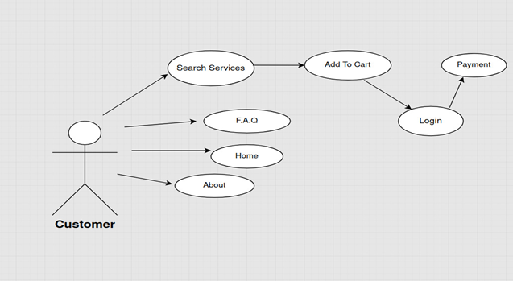

**Customer Use-Case Diagram**

* **Functional Requirements for Household Service Platform**
* **1. Customer Interaction**

1.1 **Customer Access:**

* The platform shall provide customers with access to several key sections from the homepage. These sections include "Search Services," "Frequently Asked Questions (FAQ)," "Home," and "About." Each of these sections will serve a distinct purpose in aiding the customer’s experience on the platform. For instance, the "Search Services" section will allow customers to explore and search for household services, while the "FAQ" section will answer common queries customers may have. The "Home" section will serve as the landing page, welcoming users and showcasing essential features, and the "About" section will offer insights into the platform’s mission and team.

1.2 **Navigation:**

* The platform shall provide a seamless and intuitive navigation experience for the customer, ensuring they can easily move between different sections such as "Search Services," "FAQ," "Home," and "About." Each of these sections should be accessible from the homepage and other relevant areas within the platform. Navigation should be user-friendly, with clear labels and paths, so that customers can quickly find the information or services they need without unnecessary clicks or confusion. This navigation structure will contribute to an overall positive user experience, encouraging customers to explore the platform fully.

1.3 **Search Services:**

* The platform shall offer a robust search functionality that allows customers to efficiently browse or search for a variety of household services. Customers should be able to filter their search results based on criteria such as service type, availability, price, and location. Once a service is found, the customer shall have the option to view detailed information about the service, including provider qualifications, customer reviews, and pricing. After reviewing, the customer can add the service to a cart for potential booking. The search process should be quick and responsive, ensuring customers can find the services they need with minimal effort.

1.4 **Add to Cart:**

* The platform shall provide customers with the ability to add selected household services to a virtual cart. This cart will function similarly to those found in e-commerce platforms, allowing customers to review the services they’ve selected before proceeding to checkout. Customers should be able to modify the contents of their cart, including updating service quantities, removing services, or adding new ones. The cart should also provide a summary of the total cost, including any applicable taxes or fees. This feature allows customers to manage their selections efficiently and ensures a smooth transition from service selection to booking.

1.5 **Login:**

* Before proceeding to the payment process, the platform shall require customers to log in or create an account if they have not already done so. The login process shall include fields for entering a username or email address and a password. The platform should also provide options for account recovery in case the customer forgets their login credentials. For new users, the platform shall offer a straightforward registration process that requires basic information such as name, email, and a password. By ensuring that customers are logged in before payment, the platform can securely manage customer data and provide a personalized experience.

1.6 **Payment:**

* After the customer has logged in and reviewed their cart, the platform shall allow them to proceed to the payment section. This section shall offer various payment methods, including credit/debit cards, digital wallets, and potentially other localized payment options. The platform shall securely handle the transaction process, ensuring that customer payment information is encrypted and protected. Upon successful payment, the customer shall receive a confirmation of their booking, including details of the services purchased and the scheduled time. The payment section should be designed to minimize errors and ensure a smooth and secure transaction experience.
* **2. Additional Information**

2.1 **FAQ:**

* The FAQ (Frequently Asked Questions) section shall serve as a comprehensive resource for customers, providing answers to commonly asked questions related to the platform's services, pricing, booking process, and more. This section should be organized in a clear and accessible manner, with categories that help customers quickly find the information they need. For example, there could be separate sections for service-related queries, account management, and payment issues. The FAQ should be regularly updated to reflect new questions and changes in the platform’s functionality, ensuring that it remains a reliable source of information for all users.

2.2 **Home:**

* The Home section of the platform shall serve as the primary landing page for customers, offering an overview of the platform and its offerings. This section should be visually appealing and easy to navigate, with prominent links to the most important areas such as "Search Services," "FAQ," "About," and more. The Home page may also feature highlights of popular services, customer testimonials, and any special promotions or announcements. The goal of the Home section is to engage customers from the moment they arrive on the platform, guiding them towards the services or information they are seeking in a welcoming and informative manner.

2.3 **About:**

* The About section shall provide customers with detailed information about the platform, including its mission, vision, and the team behind its development. This section should also include any relevant background information on why the platform was created and how it aims to improve the process of finding and hiring household services. Additionally, the About section may highlight the platform’s commitment to quality, security, and customer satisfaction. By providing this information, the platform can build trust with customers, helping them to feel confident in their decision to use the platform for their household service needs.
* **3. Error Handling**

3.1 **Login Errors:**

* The platform shall incorporate robust error-handling mechanisms during the login process to ensure that customers receive appropriate feedback if they encounter issues. For instance, if a customer enters incorrect login credentials, the platform shall display a clear and informative error message, such as "Incorrect username or password. Please try again." The platform should also provide options for customers to recover their account if they’ve forgotten their password, including sending a password reset link via email. This error-handling approach ensures that customers are informed of any issues and are guided towards resolving them without unnecessary frustration.

3.2 **Cart Management:**

* The platform shall implement error-handling measures within the cart management system to ensure customers are notified of any issues that may arise when adding or managing services in their cart. For example, if a customer attempts to add a service that is no longer available, the platform shall display a message indicating that the service is out of stock or no longer offered. Similarly, if there are any discrepancies in pricing or availability, the platform should immediately notify the customer and provide options to adjust their cart accordingly. These error-handling features help maintain a smooth and transparent booking process.

3.3 **Payment Errors:**

* The platform shall include comprehensive error-handling protocols within the payment section to address any issues that may occur during the transaction process. If a payment fails, the platform shall display a descriptive error message that explains the reason for the failure, such as "Payment could not be processed. Please check your payment details or try a different method." The platform should also offer customers the option to retry the payment or select an alternative payment method. These measures ensure that customers can complete their transactions successfully and are not left uncertain about the status of their booking.
* **4. Security**

4.1 **Data Protection:**

* The platform shall prioritize the protection of customer data by implementing advanced security measures, including encryption of sensitive information such as passwords and payment details. All data stored on the platform shall be protected against unauthorized access, breaches, and other security threats. Additionally, the platform shall comply with relevant data protection regulations and industry standards to ensure that customer information is handled with the utmost care. Regular security audits and updates should be conducted to address any potential vulnerabilities, ensuring that the platform remains a safe and secure environment for all users.

4.2 **Session Management:**

* The platform shall incorporate secure session management protocols to protect customer accounts and information. When a customer logs in, the platform shall create a secure session that maintains the customer's authentication status throughout their interaction with the platform. To prevent unauthorized access, the platform shall implement automatic session expiration after a period of inactivity, requiring the customer to log in again to continue. Additionally, the platform should provide customers with the ability to manually log out from their account, ensuring they can end their session at any time. These session management practices contribute to the overall security of the platform, safeguarding customer data and accounts.
  1. **NON-FUNCTIONAL REQUIREMENTS**

**2.2.1 Interface**

Go to Appendix B for user interfaces

* + 1. **Hardware Interfaces**

The Home Services is expected to function on Intel Core i3 or equivalent AMD Ryzen 3 Processor equivalent or above, 2 GB RAM, 100 GB HDD/SSD.

* + 1. **Software Interfaces**

The SPMS shall work on MS Windows operating systems family (MS Windows 10). It configures to work with MS Sql database. This System works on Internet Kestrel. A lightweight, cross-platform web server that comes built-in with ASP.NET Core. While it's often used as a backend server in conjunction with a reverse proxy like IIS or Nginx, Kestrel can also serve as a standalone server for simpler deployments.

**3. DESIGN**

**3.1 Database Design**

The following table structures depict the database design.

**Categories**

|  |  |  |  |  |  |
| --- | --- | --- | --- | --- | --- |
| **Key Type/ Constraint** | **Column Name** | **Data Type** | **Length** | **Allow Null (1=Yes; 0=No)** | **Sample Data** |
| Primary Key | CategoryID | INT | 4 | 0 | 1 |
|  | CategoryName | VARCHAR | 100 | 0 | Plumbing |

**Services**

|  |  |  |  |  |  |
| --- | --- | --- | --- | --- | --- |
| **Key Type/ Constraint** | **Column Name** | **Data Type** | **Length** | **Allow Null (1=Yes; 0=No)** | **Sample Data** |
| Primary Key | ServiceID | INT | 4 | 0 | 1 |
| Foreign Key | CategoryID | INT | 4 | 0 | 1 |
|  | Description | VARCHAR | 255 | 0 | Fix leaking faucet |

**Customers**

|  |  |  |  |  |  |
| --- | --- | --- | --- | --- | --- |
| **Key Type/ Constraint** | **Column Name** | **Data Type** | **Length** | **Allow Null (1=Yes; 0=No)** | **Sample Data** |
| Primary Key | CustomerID | INT | 4 | 0 | 1 |
|  | Name | VARCHAR | 100 | 0 | John Doe |
|  | Email | VARCHAR | 100 | 0 | john.doe@example.com |
|  | Phone | VARCHAR | 15 | 0 | 1234567890 |
|  | Address | VARCHAR | 255 | 0 | 123 Main St |
|  | Password | VARCHAR | 100 | 0 | password1 |

**Workers**

|  |  |  |  |  |  |
| --- | --- | --- | --- | --- | --- |
| **Key Type/ Constraint** | **Column Name** | **Data Type** | **Length** | **Allow Null (1=Yes; 0=No)** | **Sample Data** |
| Primary Key | WorkerID | INT | 4 | 0 | 1 |
|  | Name | VARCHAR | 100 | 0 | Alex Green |
|  | Email | VARCHAR | 100 | 0 | alex.green@example.com |
|  | Phone | VARCHAR | 15 | 0 | 2345678901 |
|  | Skill | VARCHAR | 100 | 0 | Plumbing |
|  | Password | VARCHAR | 100 | 0 | workerpassword1 |

**Status**

|  |  |  |  |  |  |
| --- | --- | --- | --- | --- | --- |
| **Key Type/ Constraint** | **Column Name** | **Data Type** | **Length** | **Allow Null (1=Yes; 0=No)** | **Sample Data** |
| Primary Key | StatusID | INT | 4 | 0 | 1 |
|  | StatusDesc | VARCHAR | 100 | 0 | Pending |

**Payments**

|  |  |  |  |  |  |
| --- | --- | --- | --- | --- | --- |
| **Key Type/ Constraint** | **Column Name** | **Data Type** | **Length** | **Allow Null (1=Yes; 0=No)** | **Sample Data** |
| Primary Key | PaymentID | INT | 4 | 0 | 1 |
|  | Amount | DECIMAL | 10,2 | 0 | 100.00 |
|  | PaymentDate | DATE |  | 0 | 2023-01-01 |

**Ratings**

|  |  |  |  |  |  |
| --- | --- | --- | --- | --- | --- |
| **Key Type/ Constraint** | **Column Name** | **Data Type** | **Length** | **Allow Null (1=Yes; 0=No)** | **Sample Data** |
| Primary Key | RatingID | INT | 4 | 0 | 1 |
| Foreign Key | WorkerID | INT | 4 | 0 | 1 |
|  | RatingValue | INT | 1 | 0 | 5 |

**WorkerPayments**

|  |  |  |  |  |  |
| --- | --- | --- | --- | --- | --- |
| **Key Type/ Constraint** | **Column Name** | **Data Type** | **Length** | **Allow Null (1=Yes; 0=No)** | **Sample Data** |
| Primary Key | WpaymentID | INT | 4 | 0 | 1 |
| Foreign Key | WorkerID | INT | 4 | 0 | 1 |
|  | WpaymentAmount | DECIMAL | 10,2 | 0 | 50.00 |
|  | WpaymentDate | DATE |  | 0 | 2023-01-15 |

**Bookings**

|  |  |  |  |  |  |
| --- | --- | --- | --- | --- | --- |
| **Key Type/ Constraint** | **Column Name** | **Data Type** | **Length** | **Allow Null (1=Yes; 0=No)** | **Sample Data** |
| Primary Key | BookingID | INT | 4 | 0 | 1 |
| Foreign Key | CustomerID | INT | 4 | 0 | 1 |
| Foreign Key | WorkerID | INT | 4 | 0 | 1 |
| Foreign Key | ServiceID | INT | 4 | 0 | 1 |
|  | BookingDate | DATE |  | 0 | 2023-01-10 |
| Foreign Key | StatusID | INT | 4 | 0 | 1 |
| Foreign Key | PaymentID | INT | 4 | 0 | 1 |

**3.2 E-R Diagram, Dataflow diagram and Class Diagram:**

Go to Appendix A

**4. CODING STANDARDS IMPLEMENTED**

### **4.1 Naming and Capitalization**

Below summarizes the naming recommendations for identifiers in Pascal casing is used mainly (i.e. capitalize first letter of each word) with camel casing (capitalize each word except for the first one) being used in certain circumstances.

|  |  |  |  |
| --- | --- | --- | --- |
| **Identifier** | **Case** | **Examples** | **Additional Notes** |
| Class | Pascal | Category, Worker, Service | Class names should be based on "objects" or "real things" and should generally be **nouns**. No ‘_’ signs allowed. Do not use type prefixes like ‘C’ for class. |
| Method | Camel | workerExists, postWorker | Methods should use **verbs** or verb phrases. |
| Parameter | Camel | CategoryDto categoryDto, id | Use descriptive parameter names. Parameter names should be descriptive enough that the name of the parameter and its type can be used to determine its meaning in most scenarios. |
| Interface | Pascal with "I" prefix | Disposable | Do not use the ‘_’ sign |
| Property | Pascal | ForeColor, BackColor | Use a noun or noun phrase to name properties. |
| Associated private member variable | _camelCase | _foreColor, _backColor | Use underscore camel casing for the private member variables |
| Exception Class | Pascal with "Exception" suffix | WebException, |  |

### **4.2. Comments**

* Comment each type, each non-public type of member, and each region declaration.
* Use end-line comments only on variable declaration lines. End-line comments are comments that follow code on a single line.
* Separate comments from comment delimiters (apostrophe) or // with one space.
* Begin the comment text with an uppercase letter.
* End the comment with a period.
* Explain the code; do not repeat it.

**5. TEST REPORT**

**Another group called Linux did the testing and the report of the testing is given hereunder.**

**GENERAL TESTING:**

|  |  |  |  |  |
| --- | --- | --- | --- | --- |
| **SR-NO** | **TEST CASE** | **EXPECTED RESULT** | **ACTUAL RESULT** | **ERROR MESSAGE** |
| 1 | Register Page | Enter the details of respected fields | OK | Nothing |
| 2 | Login Page | Dashboard/Redirected to Register page | Ok | Please enter username and password again . |
| 3 | Home | Description of Services/products | Ok | Nothing |
| 4 | Booking Details | Gives all Task Booking details | Ok | Nothing |
| 5 | Admin Page | Can create & assign bookings | Ok | Nothing |
| 6 | Worker Details | Shows all the worker details | Ok | Nothing |
| 7 | Services | Shows all the services available on the platform and allows one to directly book it. | Ok | Nothing |
| 8 | About Us | Give description about Home Services | Ok | Nothing |
| 9 | FAQ | It shows you all the most frequently asked questions | Ok | Nothing |
| 10 | Logout | It will logout from user profile. | Ok | Nothing |
|  | **STATIC TESTING** |  |  |  |
| **SR-NO** | **Deviation** | **Program** |  |  |
| 1 | Commenting not followed | All Web Application |  |  |

**6. PROJECT MANAGEMENT RELATED STATISTICS**

|  |  |  |  |
| --- | --- | --- | --- |
| **DATE** | **WORK PERFORMED** | ***SLC Phase*** | **Additional Notes** |
| May 8,2024 | Project Allotment and User Requirements Gathering | Feasibility Study | Our team met the client Mr. Rahul Sansuddi (CEO, SIIT Karad) to know his requirements. |
| May 11,2024 | Initial SRS Document Validation  And Team Structure Decided | Requirement Analysis  (Elicitation) | The initial SRS was presented to the client to understand his requirements better |
| July 28,2024 | Designing the use-cases, Class Diagram, Collaboration Diagram, E-R Diagram and User Interfaces | Requirement Analysis &  Design Phase | Database Design completed |
| August 1,2024 | Business Logic Component Design Started | Design Phase | ---------------------- |
| Aug 2,2024 | Coding Phase Started | Coding Phase | 70% of Class Library implemented. |
| Aug 4,2024 | Implementation of Web Application and Window Application Started | Coding Phase | Class Library Development going on. |
| Aug 8, 2024 | Holiday | NA | NA |
| Aug 9, 2024 | Implementation of Web Application and Window Application Continued | Coding Phase and Unit Testing | Class Library Modified as per the need. |
| Aug 9, 2024 | Implementation of Web Application and Window Application Continued | Coding Phase and Unit Testing | -- |
| Aug 10, 2024 | After Ensuring Proper Functioning the Required Validations were Implemented | Coding Phase and Unit Testing | Module Integration was done by the Project Manager |
| JAN 10, 2024 | The Project was Tested by the respective Team Leaders and the Project Manager | Testing Phase (Module Testing) | -- |
| JAN 11 2024 | The Project was Submitted to Other Project Leader of Other Project Group For Testing | Testing Phase (Acceptance Testing) | The Project of Other Team was Taken up by the Team for Testing |
| JAN 12-13, 2024 | The Errors Found were Removed | Debugging | The Project was complete for submission |
| JAN 14, 2024 | Final Submission of Project |  |  |

* 1. **DIAGRAMS & SCREENSHOTS:**

**Appendix A**

**Entity Relationship Diagram**

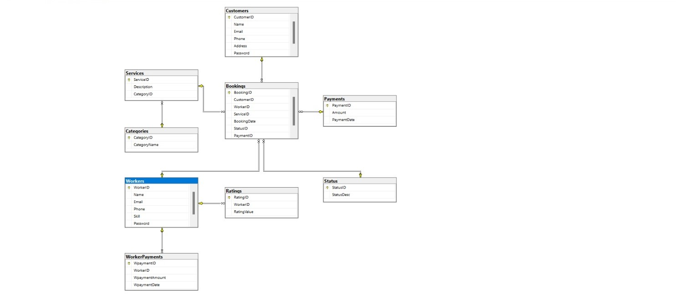

***Class Diagram:***

**Appendix B**

**Worker Use Case Diagram**

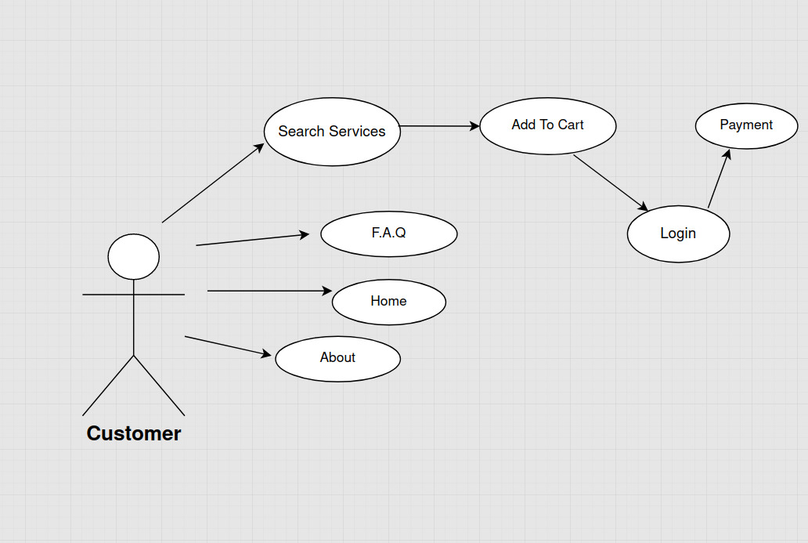

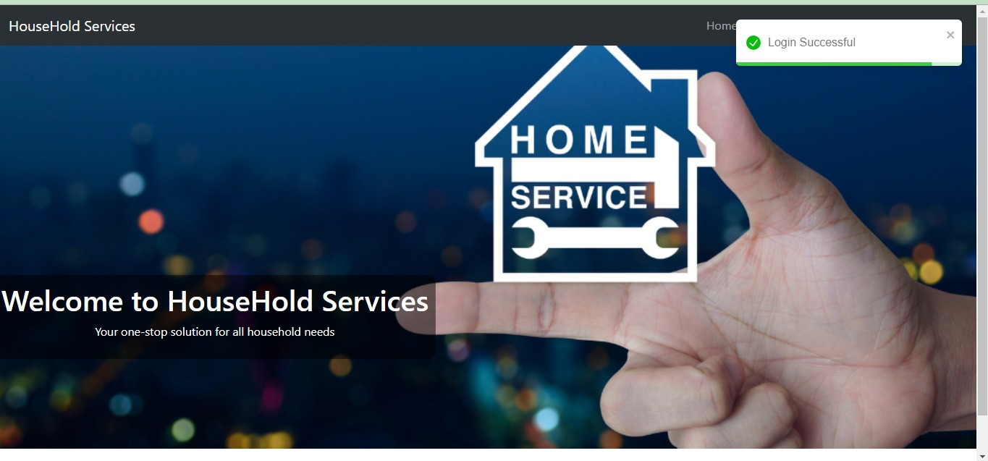**Homepage:**

**LoginPopup:**

**Administrators Login:**

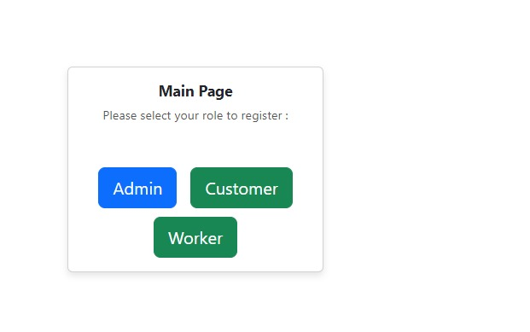

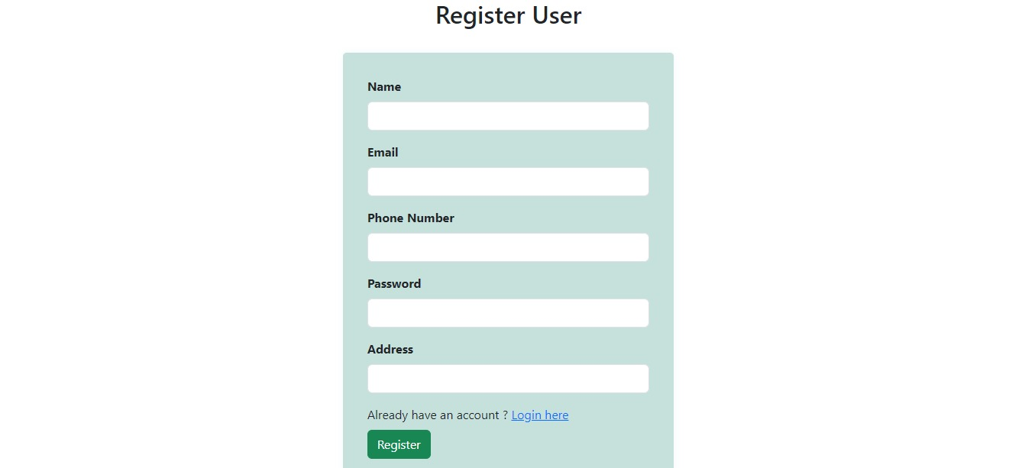**User Registration:**

**Booking Successful:**

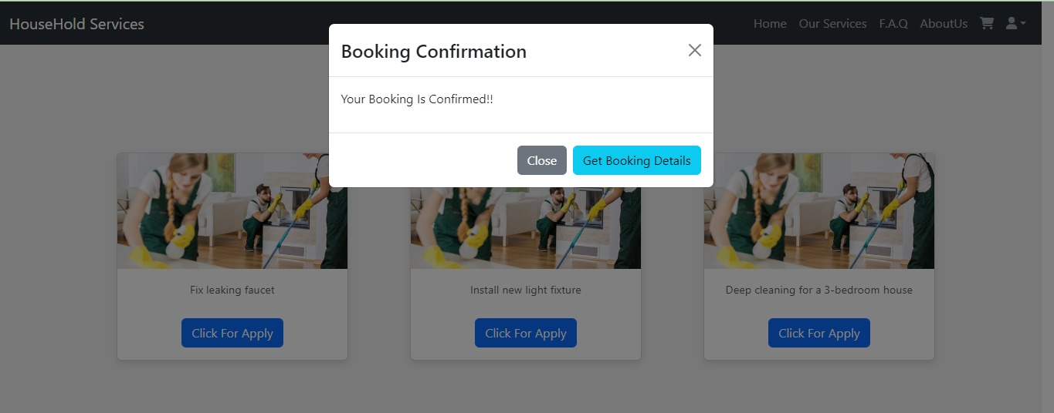

**Booking Details:**

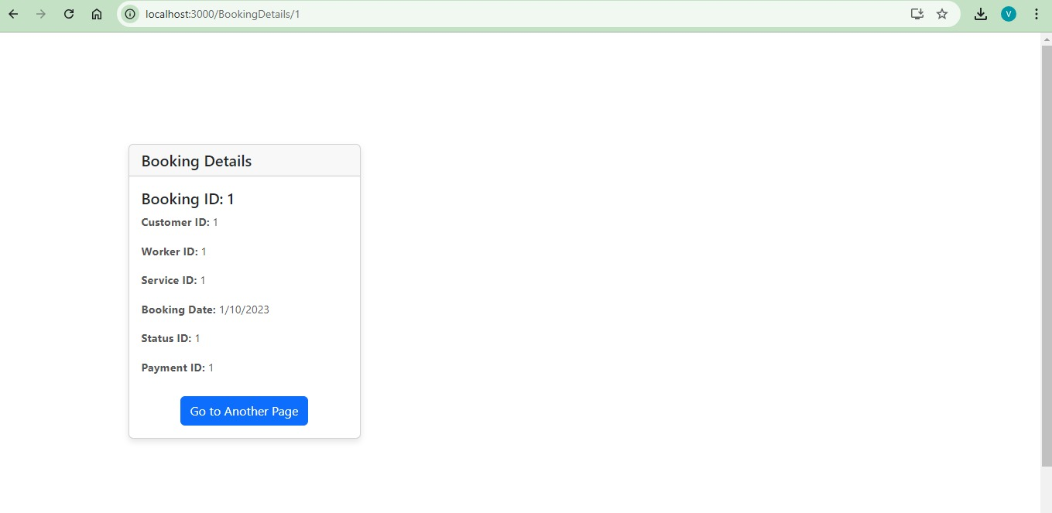

**Worker Login:**

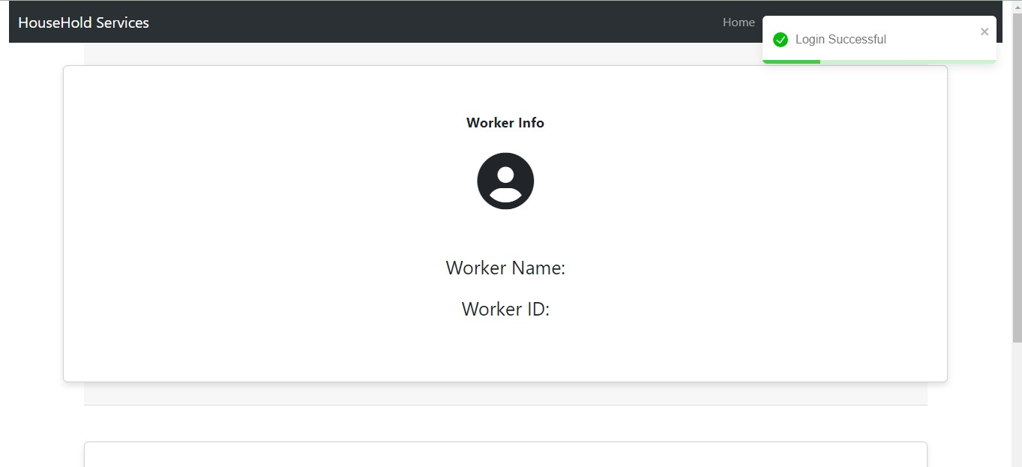

**Task Booking Details:**

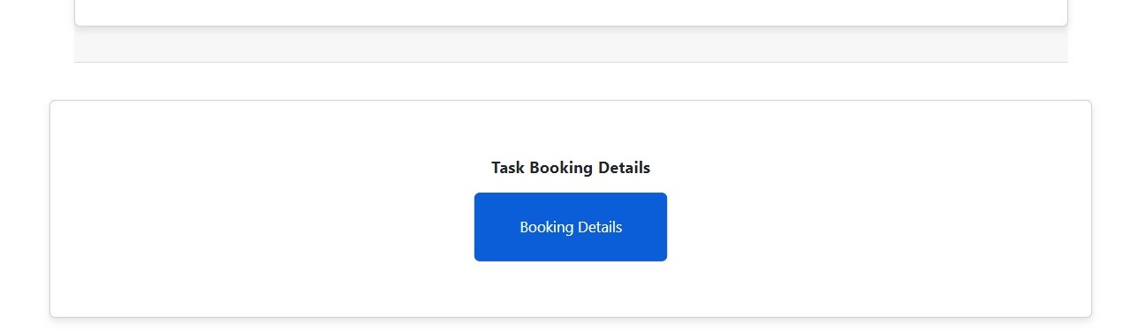

**AdminPage:**

**8. BIBLIOGRAPHY:**

1. <http://www.google.com>
2. <https://github.com/KDAC-Project>
3. http://www.webdevelopersjournal.com/
4. <https://learn.microsoft.com/en-us/aspnet/core/?view=aspnetcore-6.0>
5. <https://www.youtube.com/c/IAmTimCorey>
6. https://stackoverflow.com